THE SCHOOL AT THE HEART OF WALES

MORE ABLE AND TALENTED POLICY

  - 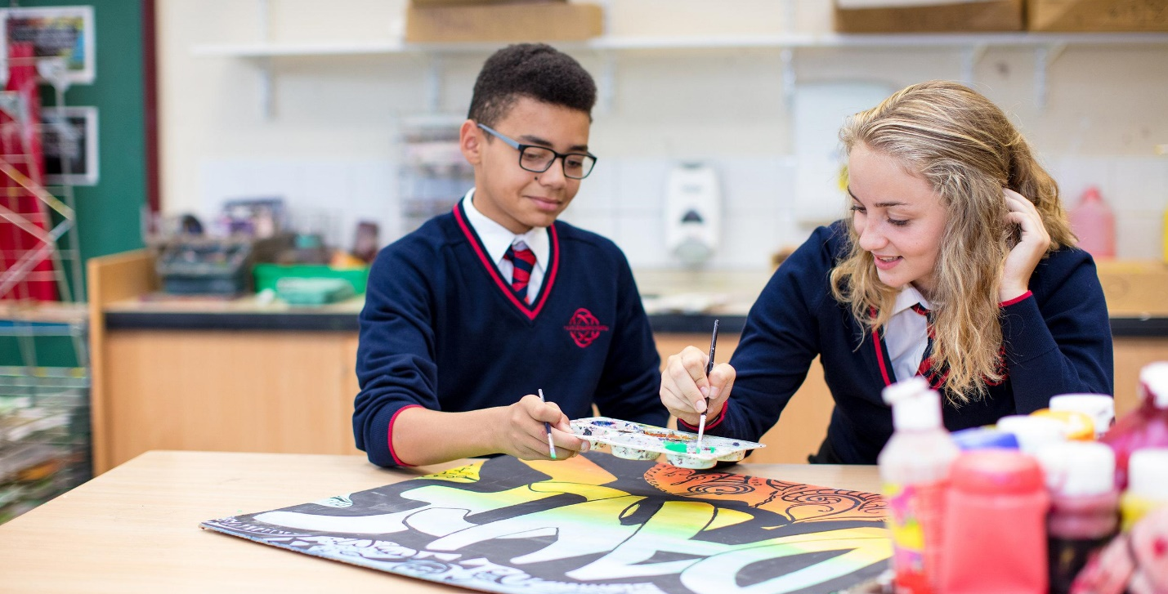

Date adopted | December 2021
Signature of Headteacher | 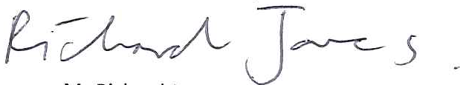
Signature of chair of governors
Review Date | September 2023

Mwy Alluog a Talentog / More Able and Talented

  - Awdur/Author: L.Jones
Adran/Department: Whole School
Dyddiad/Date: 16 November 2021

Builth Wells Campus  College Rd, Builth Wells, Powys, LD2 3BW  Tel: 01982 553 292 | Llandrindod Wells Campus  Dyffryn Rd, Llandrindod Wells, Powys, LD1 6AW  Tel: 01597 822 992

‘What makes a child gifted and talented may not always be good grades in school, but a different way of looking at the world and learning.’
Chuck Grassley, US Senator for Iowa (2005)

Contents:

Rationale and Definitions | 3
Aims | 4
Identification Strategies | 5
Provisions | 6
Monitoring and Evaluation | 7

Rationale
The Welsh Assembly has adopted the term ‘More Able and Talented’ to describe learners who require opportunities for enrichment and extension that go beyond those provided for the general cohort. ‘More Able and Talented’ learners, given extended opportunities, will not only discover but also develop their talents.
The term ‘More Able and Talented’ encompasses learners who are more able across the curriculum as well as those who show talent in one or more specific areas and strengths in leadership, team working and entrepreneurial skills. In Wales the term ‘More Able and Talented’ encompasses approximately 20% of the total school population. In every school there will be a group of learners who require greater breadth and depth of learning activities than is normally provided for the usual cohort of learners. Ability and talent can manifest themselves in many different ways, such as academic, practical, creative and social fields of human activity. The needs of more ‘More Able and Talented’ learners cannot be separated from the move to raise standards for all pupils. Research shows that schools that focus on the needs of ‘More Able and Talented’ learners improve the quality of learning and raise standards of achievement for all learners.

As a member of NACE the school will endeavour to meet the 10 quality standards of the
‘Meeting the Challenge’ guidance (Welsh Assembly Government Circular No:006/2008)

Definitions
- More Able and Talented is the general term for this concept;
- More Able is judged on standardised scores;
- Talented will be judged within curriculum and/or pastoral areas, based on criteria identified within those areas.
- Learners may be more able and/or talented in diverse fields (academic, creative, sporting, social, leadership);
- Talented learners demonstrate an innate talent or skill in creative, sporting leadership or entrepreneurial fields;
- More able and talented learners may be “high flyers”, coasters or disaffected

Aims
• To develop provision for more able and talented learners that reflects Ysgol Calon Cymru’s core values.

• To develop a curriculum that extends and enriches the learning experiences of this particular group of learners.

• To develop a range of teaching and learning strategies that extend and support our learners’ development.

- To develop a culture of aspiration amongst learners.

- To extend opportunities and support this group of learners to access extra-curricular activities.

- To work effectively in partnership with children and parents/carers to develop provision and offer support.

- To work effectively in partnership with external partners e.g. Seren Network, local business community, Universities, Careers Wales, Cluster Primaries to provide further opportunities for MAT learners.

A key objective is the provision for those learners who are identified as ‘More Able and Talented’. The school’s ethos nurtures ‘More Able and Talented’ students who are therefore always able to display their ability. Teachers are to be aware of their role in the identification of ‘More Able and Talented’ learners, and their responsibility for making the curriculum sufficiently challenging.
Our curriculum should be suitably broad, balanced and flexible to take account of the personal learning needs of more ‘More Able and Talented’ learners. High quality pastoral support ensures that more ‘More Able and Talented’ pupils make choices that are appropriately aspirational and helps secure their emotional well-being. They may need to develop higher order learning skills and problem solving techniques, work at different pace and depth, develop their motivation and more effective collaborative practices, explore their creativity or nurture skills to enable them to learn more effectively and develop personally, socially and emotionally.
Some able learners may be “coasting”; for these, we should provide a range of opportunities and sufficient challenge and stimulation in the classroom to develop their particular talent and motivate them to show what they can really achieve, reducing the risk of disaffection or underachievement.

Identification Strategies
More Able Pupils
Learners will be initially be identified as More Able on the basis of CATs scores. However, in order to maintain a flexible system, and to allow for absence or poor performance on testing day, as well as late arrivals and learners who make big improvements as they move through the school, the standardised scores from National Literacy and Numeracy tests will also be used to identify More Able learners. Progress data using the ALPS system will also be used to identify those learners who may show a high level of progress to qualify as MAT learners.
Learners with any standardised CATs score of >119 will be identified as More Able. More Able pupils will be split into the following three categories so that learners will be able to plan more specifically and appropriately:
MAT Lit
Learners with a CATs Verbal and/or National Literacy test score >119.

MAT Num
Learners with a CATs Quantative and/or National Numeracy test score >119.

MAT Gen
Learners with a CATs Non verbal score >119.

Progress Data
Ysgol Calon Cymru will adopt the ALPS system to track and monitor progress. Progress point data from assessed tasks can be included. Any learners who have shown improvement within any subject can be identified and recommended by staff for inclusion on to the MAT register.

Standardised scores will be reviewed at the end of each academic year, and the MAT Register updated accordingly. Parents of learners on the MAT Register will be informed. Once a learners is on the MAT Register, they may not be removed from it.

Talented Pupils
Pupils who are not identified as More Able might nonetheless excel in specific curriculum areas. These are our Talented Pupils. Each department is responsible for determining the criteria by which they identify Talented Pupils in each Key Stage, and for identifying Talented Pupils within their curriculum areas. These lists will then be collated by the Lead for MAT and will form the school’s Talented Register.

Provision
- Teaching staff will have high expectations of all learners. Staff will recognise the diversity of learning styles of the learners within their classes.
- Effective formative and summative assessment of student performance is made on a regular basis to support identification of Talented Pupils.
- Assessment data is published on Go4Schools marksheets as it is received. This is to enable class teachers to set academic targets for learners, and informs lesson planning and setting arrangements.
- Regular monitoring of individual student performance by the class teachers occurs with feedback to learners as a part of formative assessment procedures.
- Assessment data is used to set learners in all subjects.
- Schemes of work should include specific enrichment material.
- Course material is differentiated to maximise the challenge for all learners.
- Active encouragement of ‘More Able and Talented’ learners is provided to support projects and to enter local and national tests and competitions.

Teaching and Learning:
Teaching and learning strategies could include where appropriate:
- setting;
- varying groups to suit tasks;
- extension opportunities;
- child initiated learning opportunities;
- differentiated teacher questioning e.g. open ended questioning
- targeted use of classroom assistants;
- adopting a problem solving approach;
- focus on success criteria required for higher grades;
- adopting a skills-based approach e.g. critical thinking skills
- awareness of learning styles;
- visits by experts;
- use of more able and talented children as lead learners and/or mentors;
- acknowledging children’s success through displays/rewards/newsletters;
- encouraging identified children to share their expertise and skills, supporting others within and outside the classroom.

Extra-Curricular Opportunities:
Ysgol Calon Cymru will signpost MAT learners towards extra-curricular enrichment and challenge activities at every opportunity. Examples of these opportunities can include:
- Activities linked with the Seren Network e.g Scholars Programme
- University/Higher education outreach activities including site visits and webinars
- Careers related presentations and virtual events.
- Links with the local business community to provide work placement opportunities
- Developing links with sporting organisations and clubs.
- Leadership roles e.g. School Council; Digital Leaders
- Signposting to organisations linked to the expressive arts.

Monitoring and Evaluation:
- Responsibility for MAT lies with the SLT link member. This person is responsible for developing provision through an action plan and monitoring the identification of students and will have oversight of the provision for the academic progress of those students as they progress through Ysgol Calon Cymru.
- Progress Leaders are accountable for monitoring the ‘More Able and Talented’ students identified in their year groups.
- Responsibility for keeping and updating the More Able register and the Talented register lies with the MAT SLT Lead. The ALNCo will be responsible for helping to identify and co-ordinating the support for ‘More Able and Talented’ with other Additional Learning Needs.
- Each Curriculum Area requires its own procedure for identifying talented students which is consistent with this whole school policy.
- Class teachers are responsible for using variety of teaching strategies to challenge and meet the needs of more able and talented children (see section on Learning and Teaching).
- Class teachers are responsible for monitoring the progress of ‘More Able and Talented’ students in their class using the summative and formative assessment data they have access to, along with their professional observations.
- Form tutors are responsible for monitoring the progress of ‘More Able and Talented’ students in their tutor groups.
- The co-ordinator should liaise regularly with the governor with responsibility for More Able and Talented children;

Review:
Annually by the SLT and any revisions required submitted for approval to the Governors’ Curriculum Committee.

