THE SCHOOL AT THE HEART OF WALES

Date adopted | September 2022
Signature of Headteacher | 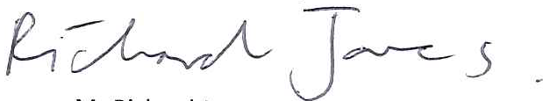
Signature of chair of governors
Review Date | September 2024

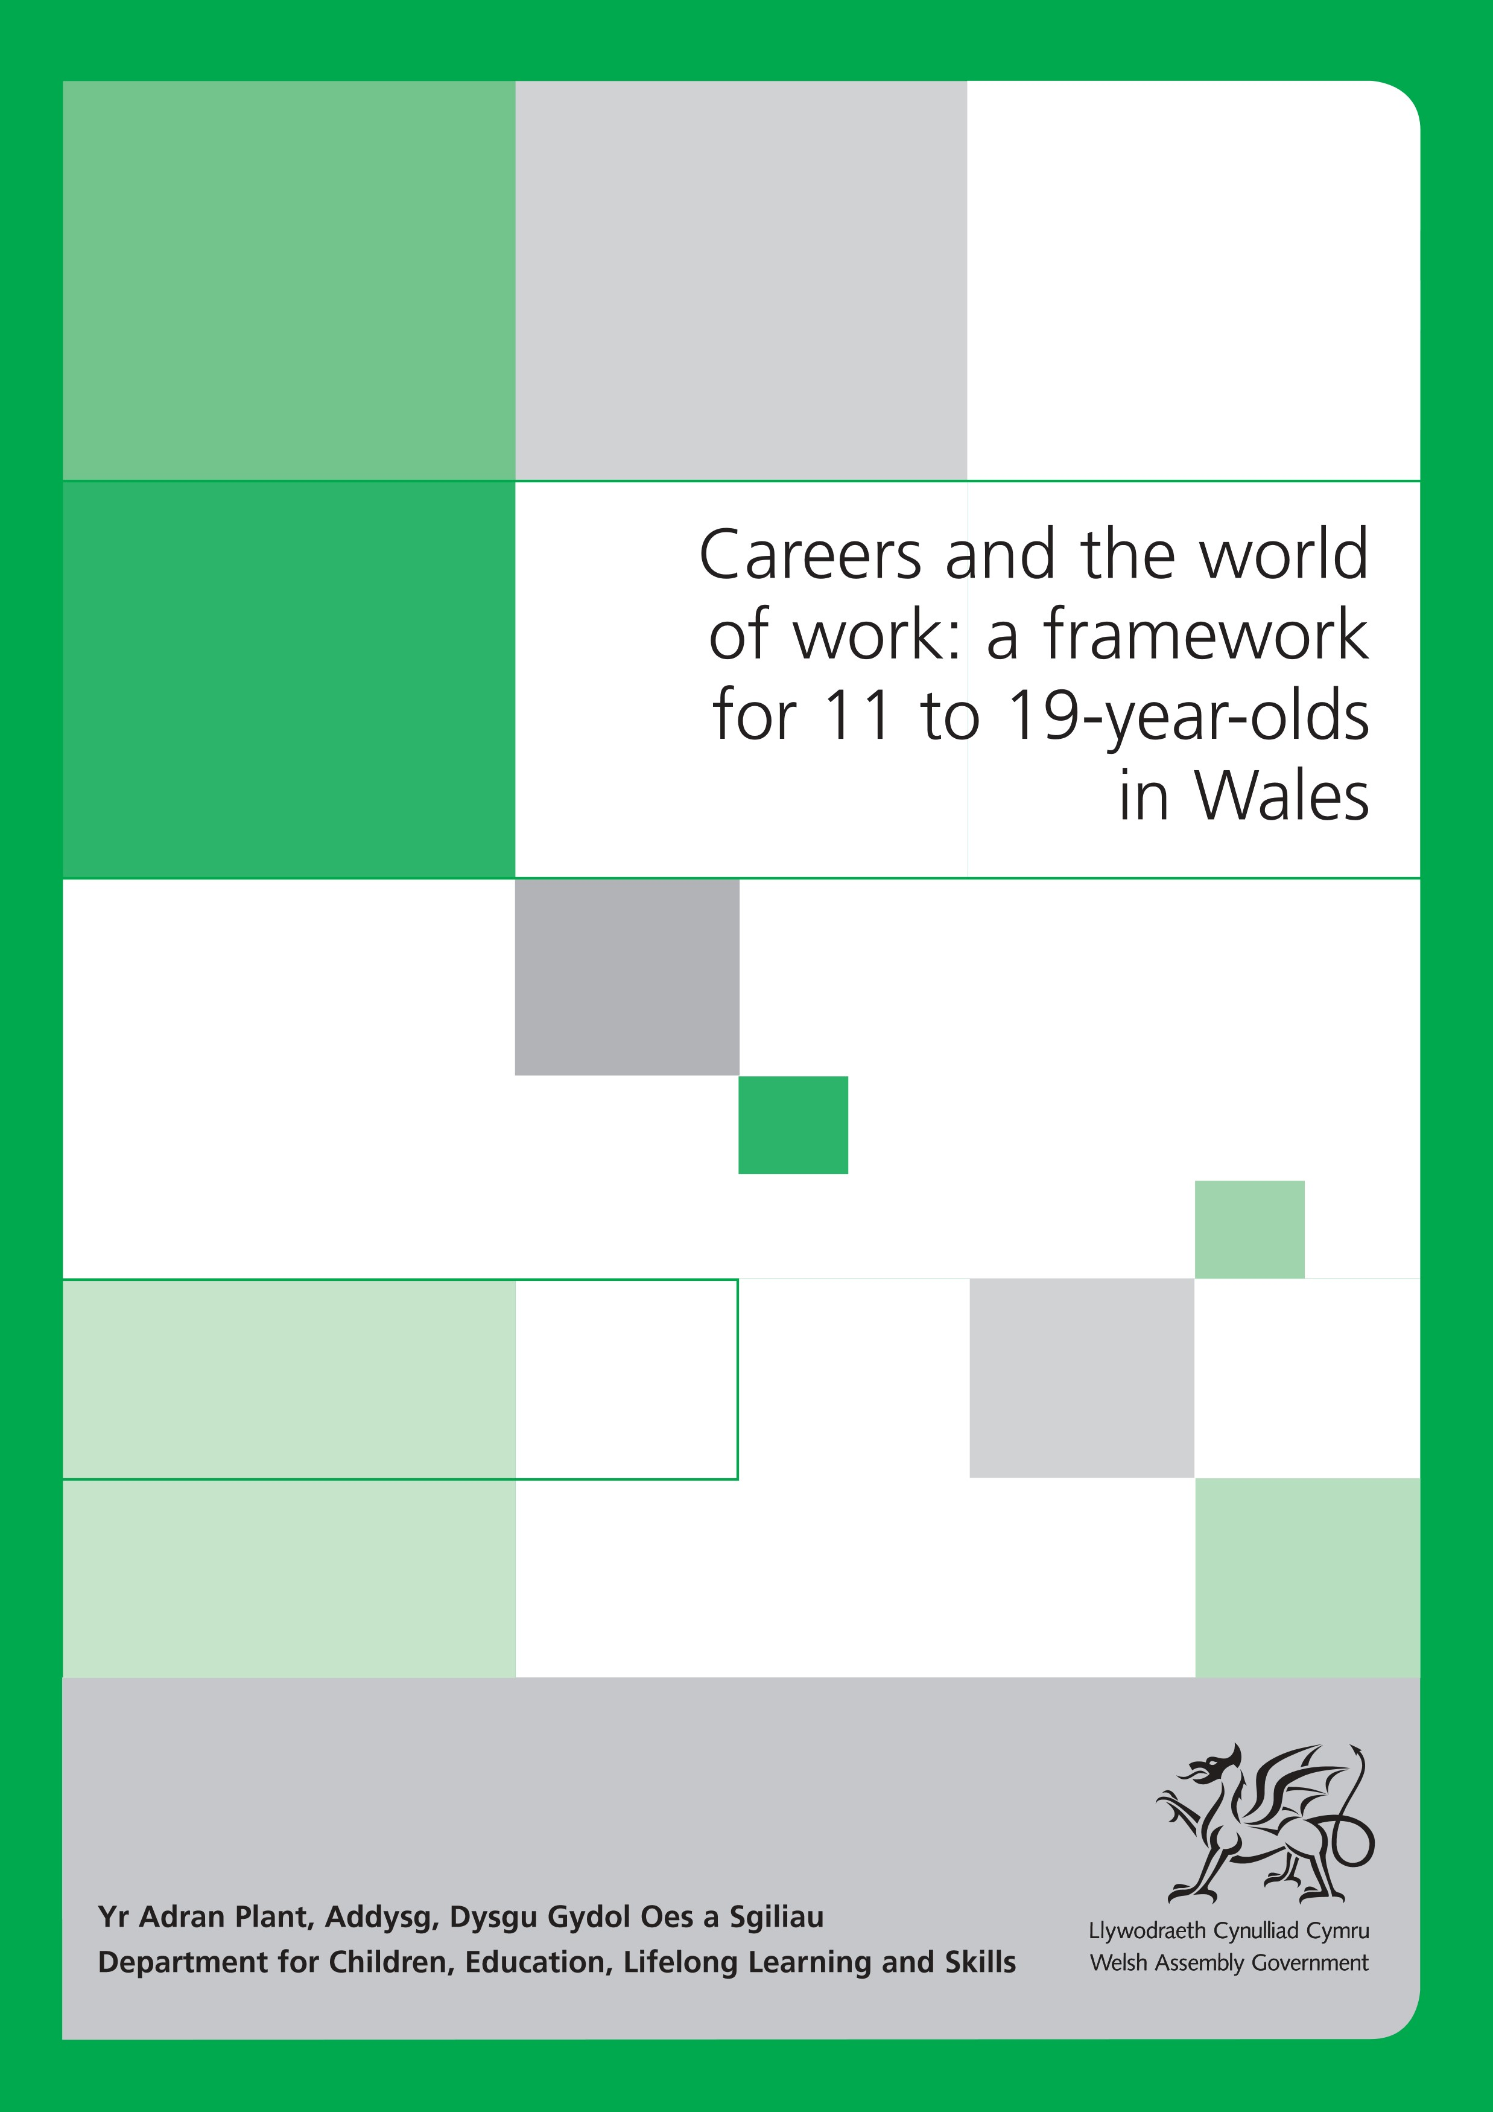

Careers and the world of work: a framework for 11 to 19-year-olds in Wales
Audience Teachers, headteachers and governing bodies of maintained schools in
Wales; colleges and other learning providers who work with 14 to
19-year-olds in Wales; local education authorities; initial teacher training
providers; teacher unions and school representative bodies; church
diocesan authorities; national bodies in Wales with an interest in education.
Overview This document sets out the Welsh Assembly Government’s requirements
for careers and the world of work for 11 to 19-year-olds in Wales. It is
issued pursuant to the powers contained in Section 108 of the Education
Act 2002 and which are vested in the Welsh Ministers. The Welsh
Ministers form part of the Welsh Assembly Government.
Action From 1 August 2008, teachers, headteachers and governing bodies of
required maintained schools, colleges and other learning providers should base
their careers and the world of work provision on this document.
Further Enquiries about this document should be directed to:
information Curriculum and Assessment 3–14 Division
Department for Children, Education, Lifelong Learning and Skills
Welsh Assembly Government
Floor 10, Southgate House
Wood Street
Cardiff
CF10 1EW
Tel: 0800 083 6003
Fax: 029 2037 5496
e-mail: C&A3-14.C&A3-14@wales.gsi.gov.uk
Additional Can be obtained from:
copies Tel: 029 2037 5427
Fax: 029 2037 5494
Or by visiting the Welsh Assembly Government’s website
www.wales.gov.uk
Ref: AC/GM/0826 January
ISBN: 978 0 7504 4430 9 A-EAC-02-01-031/KE © Crown copyright 2008
Contents
Introduction 2
Including all learners 4
Skills across the curriculum 6
Learning across the curriculum 8
Using the framework 10
Attitudes and values 13
Learning outcomesKey Stage 3 14

Key Stage 4 16
Post-16 18

Introduction
This document brings together and revises the previous frameworks for work-related education, and careers education and guidance. As such, it is part of the basic curriculum for all 11 to 16-year-olds. It is also part of the requirements of the Learning Core of Learning Pathways 14–19. The framework should be used in conjunction with the non-statutory guidance which will support understanding of how the requirements may be met in practice.
This framework sets out to offer greater clarity and manageability than its predecessors. It also seeks to move the focus more firmly towards ensuring that young people are ready to take their place in a rapidly changing world of work within the global economy.
In the twenty-first century, people have begun to understand the impact of changes in working practices. There are the calls for more flexibility in concepts of ‘career’, the demands for learning to be continuing and lifelong, and the need to adapt to changing technologies. Rather than helping young people find the ‘right’ job, schools, colleges and trainers must equip young people with the skills to manage their working life in a future that is likely to contain many changes that are presently unimagined.
Careers and the world of work (CWW) is concerned with the relationships between young people, their learning and the world of work. It should help learners to:
- explore the attitudes and values required for employability and lifelong learning
- plan and manage their pathway through the range of opportunities in learning and work
- make effective career choices
- become entrepreneurial
- flourish in a variety of work settings
- become motivated, set long term goals and overcome barriers
- see the relevance of their studies to their life and work
- develop Key Skills and other skills required by employers
- prepare for the challenges, choices and responsibilities of work and adultlife.
Well delivered, CWW will offer young people the kind of insights that generate both realism and aspiration in terms of their future life. This can only be effectively achieved through a planned programme that includes a wide range of teaching and learning experiences and environments, and including contributions from a variety of partners. These should include the best possible direct experiences of the world of work, supported by opportunities for individual advice and guidance.
It is worth making clear from the outset that the world of work is not simply the world of paid employment and that opportunities for volunteering and for community participation are an important element in developing work-related skills.
The ways in which young people will add to the wealth of Wales will be many and varied. Some will add their entrepreneurial skills to an existing company and some will start businesses of their own. The new framework explicitly recognises that young people will become employers and self-employed as well as being employees. This is why entrepreneurship is now part of the range to be covered at each stage rather than one of several desirable learning opportunities.
The requirements of this framework will not be achieved simply by classroom teaching. The person who coordinates CWW will need to ensure that a wide range of partners are involved in the delivery of this area of the curriculum. These will include subject teachers/tutors making their own area of the curriculum relevant and interesting by using the world of work as a context for learning. Equally it will involve Careers Wales, employers, entrepreneurs, advisers, parents, trainers and community groups offering relevant opportunities related to their own areas of expertise.
Such an expectation has clear implications in terms of providing the resources to secure quality provision and ensuring that this area of the curriculum is effectively represented at senior management level. The best of Welsh business is as good as the best in the world. The job of those who train, teach or tutor is to help each young person become the best he or she can possibly be.

Including all learners

Responsibilities of schools, colleges and other learning providers
Under the United Nations Convention on the Rights of the Child and the
Welsh Assembly Government’s overarching strategy document Rights to Action, all children and young people must be provided with an education which develops their personality and talents to the full. The Education Act 2002 further strengthens schools’ duty to safeguard and promote the welfare of all children and young people.
The equal opportunities legislation which covers age, disability, gender, race, religion and belief, and sexual orientation further places a duty on learning providers in Wales towards present and prospective learners to eliminate discrimination and harassment, to promote positive attitudes and equal opportunities, and to encourage participation.
Learning providers should develop in every learner a sense of personal and cultural identity that is receptive and respectful towards others. They should plan across the curriculum to develop the knowledge and understanding, skills, values and attitudes that will enable learners to participate in our multi-ethnic society in Wales. Learning providers should develop approaches that support the ethnic and cultural identities of all learners and reflect a range of perspectives, to engage learners and prepare them for life as global citizens.
Learning providers must work to reduce environmental and social barriers to inclusion and offer opportunities for all learners to achieve their full potential in preparation for further learning and life. Where appropriate, learning providers will need to plan and work with specialist services to ensure relevant and accessible learning experiences.
For learners with disabilities in particular, they should:
- improve access to the curriculum
- make physical improvements to increase participation in education
- provide information in appropriate formats.
Learning providers should seek advice regarding reasonable adjustments, alternative/adapted activities, and appropriate equipment and resources which may be used to support the full participation of all learners, including those who use a means of communication other than speech.
For learners whose first language is neither English nor Welsh, learning providers should take specific action to help them learn both English and Welsh through the curriculum. They should provide learners with material that is appropriate to their ability, previous education and experience, and which extends their language development. They should also encourage the use of learners’ home languages for learning.
Learning providers in Wales should ensure that all learners are engaged as full members of their learning communities, accessing the wider curriculum and all activities, and working wherever possible alongside their peers. Learning providers should teach all programmes of study and frameworks in ways appropriate to learners’ developing maturities and abilities, and ensure that learners are able to use fully their preferred means of communication to access the curriculum. In order to extend their learning, learners should experience a variety of learning and teaching styles.
To enable all learners to access relevant skills, knowledge and understanding at an appropriate level, learning providers may use content from earlier phases or key stages within the curriculum. They should use material in ways suitable for the learners’ age, experience, understanding and prior achievement to engage them in the learning process.
Learner entitlement
For more-able and talented learners working at higher levels, learning providers should provide greater challenge by using material in ways that extend breadth and depth of study and opportunities for independent learning. The level of demand may also be increased through the development and application of thinking, and communication, ICT and number skills across the curriculum.
Learning providers should choose material that will:
- provide a meaningful, relevant and motivating curriculum for their learners
- meet the specific needs of their learners and further their all-round development.
Learners of all abilities should have access to appropriate assessment and accreditation.

Skills across the curriculum
A non-statutory Skills framework for 3 to 19-year-olds in Wales has been developed in order to provide guidance about continuity and progression in developing thinking, communication, ICT and number for learners from 3–19.
At Key Stage 3, learners should be given opportunities to build on the skills they have started to acquire and develop. These include thinking, and communication, ICT and number skills. They should develop, practise, apply and refine these skills in a variety of contexts across the curriculum. Progress in skills can be seen in terms of applying them to tasks that move from concrete to abstract; simple to complex; personal to the ‘big picture’; familiar to unfamiliar; and supported to independent and interdependent.
For 14–19 learners, the framework should provide the basis for making effective progress in these skills, which can be assessed through a range of qualifications, including Key Skills.

Developing thinking
Learners develop their thinking across the curriculum through the processes of planning, developing and reflecting.
In careers and the world of work, learners explore, plan, develop and reflect on ideas and information, responding to others as well as to their own work.

Developing communication
Learners develop their communication skills across the curriculum through the skills of oracy, reading, writing and wider communication.
In careers and the world of work, learners communicate through various means including speaking, listening, reading, writing and the way they take part in activities. They develop these skills through practice with people both within and beyond the immediate learning environment. This is supported by their review of their own work and that of others. In doing this, they learn how to communicate effectively in a range of situations.
Learners develop their ICT skills across the curriculum by finding, developing, creating and presenting information and ideas and by using a range of equipment and software.
In careers and the world of work, learners apply technology to research and to develop knowledge and understanding of careers and work-related matters. They also use it to record and present their work appropriately.
Developing ICT

Developing number
Learners develop their number skills across the curriculum by using mathematical information, calculating and interpreting and presenting findings.
In careers and the world of work, learners find, explore and analyse data relevant to their needs as potential future employees/employers.

Learning across the curriculum
At Key Stage 3, learners should be given opportunities to build on their previous experiences, and to promote their knowledge and understanding of Wales, their personal and social development and well-being, and their awareness of the world of work.
For 14–19 learners, knowledge and understanding should be developed and applied within the contexts of their individual 14–19 pathways including the Learning Core.

Curriculum Cymreig (7–14) and Wales, Europe and the World (14–19)
Learners aged 7–14 should be given opportunities to develop and apply knowledge and understanding of the cultural, economic, environmental, historical and linguistic characteristics of Wales. Learners aged 14–19 should have opportunities for active engagement in understanding the political, social, economic and cultural aspects of Wales as part of the world as a whole. For 14–19 learners, this is a part of their Learning Core entitlement and is a requirement at Key Stage 4.
Careers and the world of work contributes particularly to economic understanding through its researching of learning, careers and employment opportunities. The changing nature of those opportunities will often also highlight linguistic, historical and environmental matters within the area and further afield.

Personal and social education
Learners should be given opportunities to promote their health and emotional well-being and moral and spiritual development; to become active citizens and promote sustainable development and global citizenship; and to prepare for lifelong learning. For 14–19 learners, this is a part of their Learning Core entitlement and is a requirement at Key Stage 4.
Careers and the world of work contributes to this through contacts with the world of work and by challenging stereotypes. It also provides opportunities to develop their understanding of social interaction through working with others.
Learners aged 11–19 should be given opportunities to develop their awareness of careers and the world of work and how their studies contribute to their readiness for a working life. For 14–19 learners, this is a part of their Learning Core entitlement and is a requirement at Key Stage 4.
Careers and the world of work
Careers and the world of work will operate most effectively when it is evident across the whole learning experience of a young person.

Using the framework
This framework covers 11 to 19-year-olds. However, understanding of the world of work can begin at any age. In particular, the Key Stage 2 learning outcomes for personal and social education (PSE) include a requirement for students to consider the range of jobs carried out by people in their community. The frameworks for CWW and PSE have been developed alongside each other in order to minimise overlap and are usefully considered together. Where they are managed or taught separately, it should be with an understanding that they will only work effectively if they are treated as close partners.
The framework itself is divided into three elements:

• attitudes and values
- skills
- range.

Attitudes and values
Many of the discussions with employers and educators in the development of this document emphasised the importance of how young people approach work. As a consequence of this, the document sets out attitudes and values that will contribute to a person’s employability. There are no hard and fast definitions of what constitutes attitudes or values. In other contexts, some of these ‘attitudes’ may be described as ‘dispositions’. Whatever name is attached, there is a consensus that what is described here needs to underpin education and training. For example, a gifted learner without flexibility or enthusiasm is likely to struggle to gain appropriate employment. This element of the framework applies across the whole age range.

Skills
At each stage, the most likely outcomes in terms of skills are detailed. Many skills remain similar across the stages but with increasingly demanding and complex contexts. The skills will inform both the preparation of materials/activities and any review of the coverage achieved in a particular programme. Many situations will offer opportunities to practise several skills during one activity.
The range statements for each stage indicate the contexts in which skills, attitudes and values can be developed and will inform the programme content provided by schools, colleges and trainers. They are sub-divided into five parts.

• Personal achievement
Learners need to know both where they are now and where they aspire to be in times to come.

• Seeking information
The starting point for moving on is to find out, first of all, what is realistically available in the world of work. Without this stage, decisions could be made that are uninformed, out-of-date and misleading.

• Understanding the world of work
The process of finding out is not simply a theoretical exercise. It is one thing to know what is ‘out there’ on paper; it is quite another to get a sense of what particular jobs and careers feel like. Good career decisions are based on self-awareness and a real knowledge of the world of work: the good and the bad, the stimulating and the boring. Learners will also need to be flexible and enterprising, whether they eventually become employees, employers or self-employed.
Range

• Guidance
Decisions about what routes to pursue in life are rarely taken alone and an important element in careers and the world of work is the guidance and advice of others. The framework encourages both the seeking and the giving of advice while recognising that the decision is made by the individual choosing the learning pathway or the career path.

• Making and implementing decisions
A choice may only take a moment or it may seem to take an interminable time to reach. However short or long the process, decisions alone are not enough. Young people have to be able to present themselves in a positive and credible light so that organisations, including colleges, universities, trainers, employers and financial institutions, are convinced that they are worthy of a chance.

Underlying any preparation for the world of work is the need for positive attitudes so that employers and customers will want what someone has to offer. This is an ongoing process which begins in the earliest years and continues throughout life.
Most people will have their own slightly different views about which are the most important attitudes and values in the workplace. There will also be differences of opinion about what is essentially attitudinal and what is better described as a skill. However here is a range of attributes commonly considered as important by employers, entrepreneurs, admissions tutors and careers specialists:
Attitudes and values (11–19)
• | honesty
• | reliability/trustworthiness
• | helpful and respectful attitudes to others
• | flexibility
• | awareness of others’ needs
• | willingness to work in a team
• | willingness to take responsibility/the initiative
• | enthusiasm/self-motivation
• | willingness to be innovative
• | self-discipline
• | perseverance
• | readiness to overcome fear
• | readiness to go on learning.
There is little evidence that these attributes can be taught in any didactic sense but there are plenty of examples of these attitudes being fostered when young people are engaged in relevant, interesting and practical activities within a climate that encourages both cooperation and self-esteem. There is no requirement for providers to assess student achievement in terms of their attitudes and values. In institutional self-assessment processes, providers may wish to consider whether activities provide opportunities for these kinds of attitudes and values to be developed.

Key Stage 3 learning outcomes

Learners should be able to develop their skills, attitudes and values through a range of contexts. They should have the opportunity to:

Personal achievement
- describe their abilities, interests and skills
- list their achievements in and out of school

Seeking information
- use a variety of sources to search for information about a range of work and learning opportunities
Range
Learners should be given opportunities to:
1.
work both independently and cooperatively
2.
listen attentively and respond helpfully
3.
access an appropriate range of sources for
help, support and advice within defined
contexts
4.
locate, select and summarise
information, identifying key points
5.
select and interpret data about
learning
and career opportunities
6.
use ICT to find, check and use
relevant
information
7.
consider their own and other people’s
ideas about learning, careers and the
world of work to inform opinions and
decisions
8.
develop a range of ideas to solve
problems
9.
communicate clearly in English or Welsh,
as appropriate, about careers and the world
of work
Skills
- find out about the different types of work that are available and how work patterns are changing

Understanding the world of work
- recognise and challenge the stereotypes that limit people in their choice of work and careers
- explore the attributes of entrepreneurs and the role of enterprise in wealth creation
- learn about the personal qualities that employers see as important

Guidance
- identify the people able to provide informed advice and guidance on subject choices/career ideas and understand the implications of the possible pathways ahead of them
- identify any obstacles to future plans and decide how they might be overcome
10.
organise information about themselves
clearly and positively
11.
plan, agree and review targets
12.
manage time within given structures
13.
adapt to new situations
14.
be able to apply learning to a range
of situations.

Making and implementing decisions
- use what they have discovered about themselves, learning and work in decisions about individual Key Stage 4 pathways
- be able to explain their proposed choices both to their peers and to appropriate adults.
Key Stage 4 learning outcomes
Range
Learners should be given opportunities to:
1.
work both independently and cooperatively
within the classroom and beyond
2.
listen attentively and respond helpfully
noting strengths and weaknesses of views
3.
access a wide range of sources for help,
support and advice
4.
locate, select and identify key points from a
range of information, including any lines of
reasoning
5.
select, compare and interpret data
relevant to their own needs
6.
use ICT to find information that is
accurate and relevant for a range of
purposes
7.
consider their own and other people’s
perspectives about learning, careers
and the world of work to inform opinions
and decisions
8.
seek out and evaluate innovative
solutions to problems
9.
communicate coherently in English or Welsh,
as appropriate, about careers and the world
of work
10.
present information about themselves
effectively in a variety of forms
Skills
Learners should be able to develop their skills, attitudes and values through a range of contexts. They should have the opportunity to:

Personal achievement
1. develop a curriculum vitae (CV) based on their achievements, abilities, interests and skills

Seeking information
- use a variety of sources to find information about their career ideas, differentiating between information and promotional material
- examine employment and learning opportunities and trends both locally and further afield

Understanding the world of work
- examine the implications of stereotyping in employment and training, recognising the benefits of a positive attitude to difference and diversity
- explore the role of enterprise/wealth creation and develop their own ability to act in entrepreneurial ways
- recognise their responsibilities and rights as employees and learn how to follow safe working practices
- use work-focused experiences to understand better what skills and personal qualities employers want

Guidance
- access realistic, impartial guidance on learning, careers and work-related matters
- understand the prospects and progression patterns in the jobs in which they are interested
- examine their careers ideas and the potential effects on their lives
- identify any obstacles to future aspirations and plan thoughtfully how they might be overcome

Making and implementing decisions
11.
plan, set targets and review/reflect on
learning
12.
manage time with some independence
13.
adapt to a range of new situations
14.
be able to apply learning to a range
of situations both within and outside
school
15.
show emerging awareness of customer
needs.
- identify, understand and make decisions about individual pathways in education, training and work
- be able to explain in some detail their choices both to their peers and to appropriate adults
- review current information about themselves in relation to learning and work in order to negotiate a career plan
- promote a positive self-image when making applications and attending interviews.
Post-16 learning outcomes
Range
Learners should be given opportunities to:
1.
work both independently and cooperatively
in a wide range of settings
2.
listen attentively and respond effectively,
making significant contributions to
discussions
3.
access independently a wide range of
sources for help, support and advice
4.
select, summarise and synthesise key ideas
and information
5.
select, compare and interpret data
from a variety of situations relevant
to their own needs
6.
use ICT selectively and efficiently to
find, develop and synthesise
information so that it is fit for purpose
7.
explore their own and other people’s
assumptions and aspirations and
make best use of this in their
decision-making
8.
use innovative approaches to identify
opportunities and solve problems
9.
communicate confidently and coherently, in
English or Welsh, as appropriate, about
careers and the world of work in a wide
range of contexts
Skills
Learners should be able to develop their skills, attitudes and values through a range of contexts. They should have the opportunity to:

Personal achievement
- review their achievements and their work/career/study plans
- continue to develop an ongoing curriculum vitae (CV) based on their achievements, experiences, interests and skills in order to enhance their employability

Seeking information
- research and evaluate a range of information about careers and the labour market within Wales
- explore how opportunities in Britain, Europe and the rest of the world might impact upon their career ideas
- expand their knowledge of business and self-employment opportunities in order to inform their career horizons
- discuss the impact of current trends in working patterns on their career plans

Understanding the world of work
- discuss the benefits that diversity can bring to the workplace and the disadvantages that can be created by stereotyping
- engage in activities that encourage an entrepreneurial approach to work and wealth creation
- understand their responsibilities and rights as employees and know how to follow safe working practices
- use work-focused experiences to gain a better understanding of what skills and qualities employers require and any implications for their career/work plans

Guidance
- access and analyse realistic, impartial guidance on education/career/work routes
- consider the financial and lifestyle implications of their career ideas

Making and implementing decisions
10.
present information about themselves
effectively in a variety of forms for different
audiences
11.
plan, set targets across several time spans
and review/reflect on learning
12.
manage time independently, meeting tight
deadlines
13.
adapt to challenging new situations
14.
be able to apply learning in a wide
range of familiar and unfamiliar
settings
15.
show increasing awareness of customer
needs.
- understand, analyse and make decisions about individual pathways in education, training and work
- be able to explain and justify their choices both to their peers and to appropriate adults
- review, synthesise and present information about themselves in relation to learning and work in order to negotiate a career plan
- promote a positive self-image in a range of formal situations including applications and attending interviews.

Notes

