THE SCHOOL AT THE HEART OF WALES | 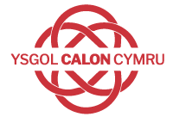

Curriculum l Policy

Date adopted | September 2022
Signature of Headteacher | 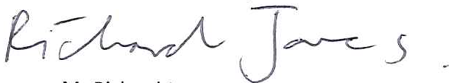
Signature of chair of governors
Review Date | September 2024

www.powys.gov.uk
Powys Professional Learning Team
The Powys Curriculum Statement
“If we teach tomorrow as we did today, we rob our children of their future.”
-John Dewey

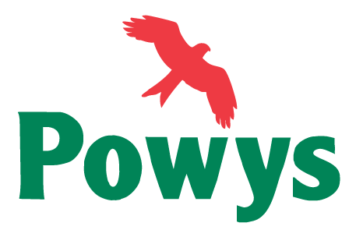

Introduction
This statement revises and updates the Powys Local Authority Curriculum statement of 1996. It is intended to:
- Express the educational philosophy of Powys Local Authority
- Support schools in developing their own curriculum, starting at the four purposes, in line with the Welsh Government’s requirements for schools
- present ‘Curriculum for Wales; The Essentials’ which summarises the key components of Curriculum for Wales.

Curriculum for Wales:
The Essentials

‘Curriculum for Wales: The Essentials’ provides a summary of the Curriculum for Wales Framework. It outlines they key components, with the four purposes being at the heart of the curriculum.

Aim
Our aim is to help each school to develop its own curriculum, enabling their learners to develop towards the four purposes of Curriculum for Wales.

“If we create a culture where every teacher believes they need to improve, not because they are not good enough, but because they can be even better, there is no limit to what we can achieve”
-Dylan William

Four Purposes
The Four Purposes are the shared vision, starting point and aspiration of every child and young person in Powys. In fulfilling these, we set high expectations for all, promote positive wellbeing, tackle ignorance, and encourage critical and civic engagement

Purpose: ambitious, capable learners who:

- set themselves high standards and seek and enjoy challenge
- are building up a body of knowledge and have the skills to connect and apply that knowledge in different contexts
- are questioning and enjoy solving problems
- can communicate effectively in different forms and settings, using
both Welsh and English
- can explain the ideas and concepts they are learning about
- can use number effectively in different contexts
- understand how to interpret data and apply mathematical concepts
- use digital technologies creatively to communicate, find and analyse information
- undertake research and evaluate critically what they find
and are ready to learn throughout their lives

Purpose: enterprising, creative contributors who:
- connect and apply their knowledge and skills to create ideas and products
- think creatively to reframe and solve problems
- identify and grasp opportunities
- take measured risks
- lead and play different roles in teams effectively and responsibly
- express ideas and emotions through different media
- give of their energy and skills so that other people will benefit
and are ready to play a full part in life and work
Purpose: ethical, informed citizens who:

- find, evaluate and use evidence in forming views
- engage with contemporary issues based upon their knowledge and values
- understand and exercise their human and democratic responsibilities and rights
- understand and consider the impact of their actions when making choices and acting
- are knowledgeable about their culture, community, society and the world, now and in the past
- respect the needs and rights of others, as a member of a diverse society
- show their commitment to the sustainability of the planet

and are ready to be citizens of Wales and the world

Purpose: healthy, confident individuals who:

- have secure values and are establishing their spiritual and ethical beliefs
- are building their mental and emotional well-being by developing confidence, resilience and empathy
- apply knowledge about the impact of diet and exercise on physical and mental health in their daily lives
- know how to find the information and support to keep safe and well
- take part in physical activity
- take measured decisions about lifestyle and manage risk
- have the confidence to participate in performance
- form positive relationships based upon trust and mutual respect
- face and overcome challenge
- have the skills and knowledge to manage everyday life as independently as they can

and are ready to lead fulfilling lives as valued members of society.

Requirements of Schools

Schools must design, adopt and implement a curriculum that:
- enables learners to develop in the way described in the four purposes
- is broad and balanced
- is suitable for learners of differing ages, abilities and aptitudes
- provides for appropriate progression for learners and includes a range of provision to ensure this.

A school curriculum must:
- contain the six areas of learning and experience
- encompass the statements of what matters (as set out in the statements of what matters code)
- reflect the principles of progression set out in the progression code
- include the mandatory curriculum elements
- encompass the mandatory cross-curricular skills.

For learners up to age 7:
- the headteacher will have the discretion to decide that English does not form part of the school’s curriculum in order to enable learners to gain fluency in Welsh
- all schools must set out in their published summary of their curriculum their approach to teaching English and Welsh up to age 7.

For learners aged 14 to 16, a school must design a curriculum so that, in addition to the mandatory curriculum elements and mandatory cross-curricular skills, it provides:
- choice for learners in the other learning they will undertake, but in such a way that ensures all learners still undertake some learning in each Area
- include other elements which the school requires all learners (or some groups of learners) to undertake.
Welsh Government, Curriculum for Wales Guidance, 2020.

