THE SCHOOL AT THE HEART OF WALES

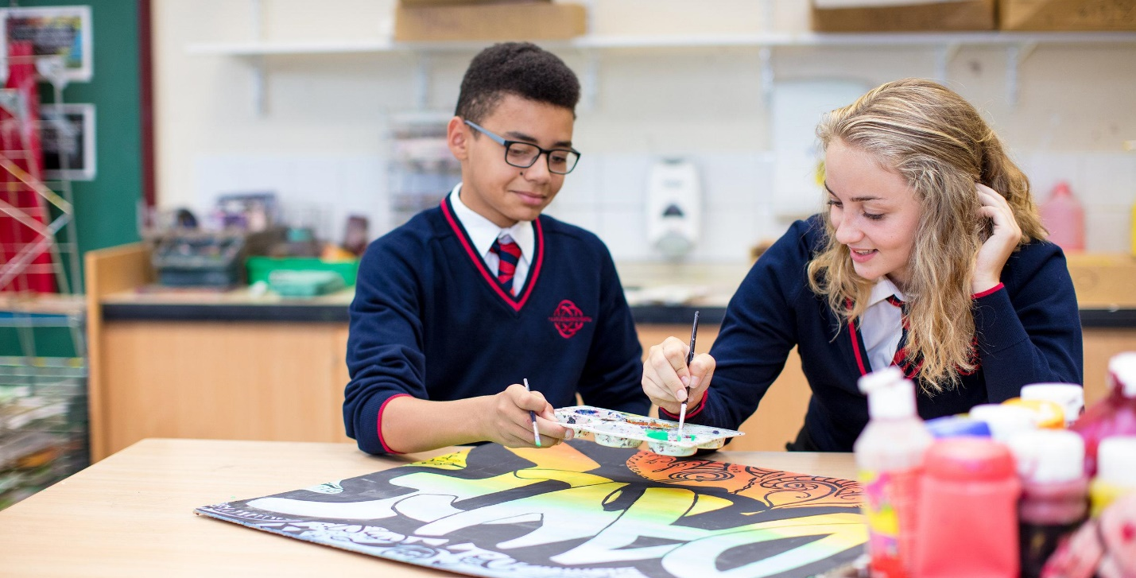

Date adopted | February 2022
Signature of Headteacher | 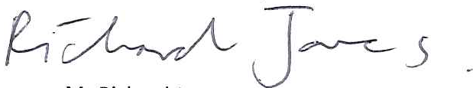
Signature of chair of governors
Review Date | February 2024

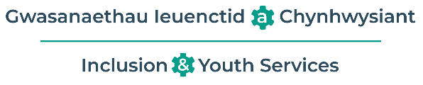
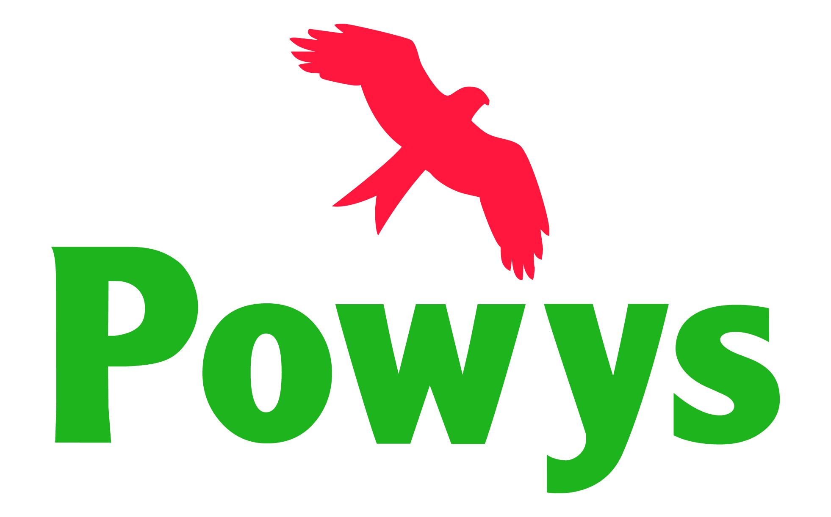

School Policy for
Supporting the educational outcomes for Children Looked After (CLA)

At Ysgol Calon Cymru the designated teacher for CLA is –Rhiannon Rhys Jones

The link Governor responsible for CLA is –Sharon Hammond

Introduction
Many children and young people who are in care have suffered abuse or neglect. Despite having as broad a range of abilities as their peers, Children Looked After are particularly vulnerable to underachievement. Nationally, Children Looked After (CLA) significantly underachieve and are at greater risk of exclusion compared with their peers. Their academic and social progress is likely to be affected by their experience and compounded by instability in their personal circumstances.
Helping CLA succeed and providing a better future for them is a key priority in our school. Our school recognises that Children Looked After can experience specific and significant disadvantage within a school setting, and we are committed to ensuring that they reach their potential in all areas.
We are aware that some Children Looked After may have specific difficulties in obtaining transport and attendance, completing homework, getting parental consent for activities, obtaining funding for extra activities, obtaining correct uniform and equipment, as well as possible stigma about their circumstances. We recognise that Children Looked After may have very specific needs and may be coping with trauma, abuse or rejection, and are likely to experience personal distress and uncertainty.

Children Looked After may (or may not) experience some of the following difficulties:
- low self esteem
- poor education achievement due to time out of school
- unidentified additional learning needs owing to frequent placement moves
- poor engagement owing to the factors above
- delayed social/emotional/ cognitive development
- prone to mental health issues
- isolated with few opportunities to interact with peers
- present with challenging behaviour
- demonstrate complexities in attachments to others.
- have a need to be very private

This makes children looked after an extremely vulnerable group in terms of education and future life chances.
At Ysgol Cefnllys we believe that the educational experience of all children should be positive and powerful, and we aim to provide a learning environment in which every Child Looked After can be successful. We believe that this school has a major part to play in ensuring that our CLA are able to be healthy, stay safe, enjoy, achieve, make a positive contribution to society and achieve economic wellbeing
Aims
The aims of the school with relation to CLA:
- To work closely with the virtual school for CLA to ensure the best possible educational outcomes for LAC.
- To ensure that all policies and procedures are followed for CLA as for all children and young people.
- To ensure that CLA have access to a broad and balanced curriculum.
- This should be reflected within the Personal Education Plan (PEP), to provide a differentiated curriculum and additional interventions as required appropriate to the individual’s needs.
- To ensure that CLA take as full a part as possible in all school activities.
- To ensure that parents, carers and social workers of CLA are kept fully informed of their child’s progress and attainment.
- To ensure that CLA are involved, where practicable, in decisions affecting their future provision.
The school and the governing body endorse the Powys County Council policy and welcomes CLA who may be looked after by our local authority or those who may be in the care of another authority but living in Powys. Our approach to encouraging and supporting the educational achievement of Children Looked After is based on the following principles:

- Ensuring an appropriately trained Designated Teacher is appointed, who will be responsible for all Looked After children.
- Appoint a link Governor for CLA
- All Looked After Children will have a TYFU profile and a Personal Education Plan (PEP) drawn up between the school, the child, and the child’s social worker (through Specialist Teacher for CLA), which will identify the child’s individual needs and the support they require
- Prioritising reduction in exclusions and promoting attendance
- Working with the wider corporate parenting team

Roles and responsibilities
The governing body will
- Ensure the school has a coherent policy for CLA
- Agree the school’s policies and procedures in conjunction with legislation and statutory guidance
- Ensure that all Governors are fully aware of the legal requirements and guidance on the education of Looked After Children
- Ensure that the school has an overview of the needs and progress of Looked After Children.

The head teacher will
- Ensure that the school has a Designated Teacher who has the same prominence as that of an ALNCO, and that the Designated Teacher is enabled to carry out his or her responsibilities as below.
- Ensuring the designated teacher for CLA has received the appropriate training.
- Allocate resources to meet the needs of Looked After Children to ensure equal access to the curriculum.
- Ensure that procedures are in place to monitor the admission, progress, attendance and any exclusion of Looked After Children and act where progress, conduct or attendance is below expectations.
- Ensuring that all members of staff are aware that supporting CLA is a key priority.
- Promoting and actively challenging negative stereotypes of CLA and promoting attachment and trauma informed approaches to understanding behaviour as a communication.
- Ensure reporting of CLA on Head teacher reports to include the number of CLA, their attendance as a vulnerable group in relation to other learners.

The designated teacher for CLA will
- Ensure a welcome and smooth induction for the child and their carer, using the Personal Education Plan to plan for that transition in consultation with the child’s social worker and arrangements are put in place to ensure their needs identified and met.
- Build relationships with health, education and social care partners and other partners so that they and the Specialist Teacher for CLA understand the support available to CLA.
- Ensure that the personal education plan is completed with the child, social care, foster carer and any other relevant people in a timely manner.
- Act as the main contact for social services and the Specialist Teacher for CLA.
- Gain the knowledge and skills to advise and support staff on teaching and behaviour strategies for CLA.
- Ensure that CLA are prioritised for one-to-one tuition and support.
- Support new CLA admissions to the school
- Liaise with the ALNCO to ensure all pupil needs are met.
- Maintain an up-to-date record of the Looked After Children in school, including those in the care of other authorities and ensuring all necessary information is passed to other staff as required
- Track academic progress and target support appropriately
- Establish and maintain regular contact with home, statutory and voluntary agencies.
- Ensure confidentiality for individual pupils, sharing personal information on a need to know basis.
- Promote inclusion in all areas of school life and encourage Looked After Children to join in extracurricular activities and out of school learning.
- Be pro-active in supporting transition and planning when moving to a new phase in education.
- Ensure that attendance is monitored.
- Attend training as required to keep fully informed of latest developments and policies regarding Looked After Children.

Personal education plans (PEPs)
- All CLA must have a care plan; PEPs are an integral part of this care plan.
- The ePEP is an evolving record of what needs to happen for a pupil to enable them to make at least the expected progress and fulfil their potential.
- The ePEP will reflect the importance of a personalised approach to learning which meets the identified educational needs of the child.
- The school will work with other professionals and the child’s carers to use the ePEP to support the child’s educational needs, raise the child’s aspirations and improve their life chances.
- All relevant bodies, such as the LA, the designated teacher and carers, will involve the child in the ePEP process at all stages, when appropriate.

Working with agencies and the CLA education
- The school will ensure that copies of all relevant reports are forwarded to the social workers, in addition to parents/carers or residential social workers.
- The school will coordinate their review meetings; for example, hold their annual review at the same time as a PEP review.
- The school will work with other agencies to exchange information such as changes in circumstances, exclusions or attendance issues.
- The designated teacher for CLA will communicate with the Specialist Teacher for CLA and child’s social worker to facilitate the completion of the PEP.
- The designated teacher will ensure prompt, consistent and strong communication with the Specialist Teacher for CLA regarding CLA who are absent without authorisation.

Exclusions
Past experiences of CLA will be considered when designing and implementing the school’s Behaviour Policy, ensuring that it is suitably flexible and inclusive. Where the school has concerns about a child’s behaviour, the Specialist Teacher for CLA will be informed at the earliest opportunity.
Exclusion will only be considered as a last resort. Where a fixed term exclusion is considered the school will consult with the Specialist Teacher for CLA prior to the exclusion and Powys County Council’s lead safeguarding and attendance officer, Michael Gedrim. to consider what additional support can be provided to prevent exclusion.

Legal framework
This policy has due regard to legislation and statutory guidance, including, but not limited to, the following:
Children Act 1989
Section 52 of the Children Act 2004
Section 20 of the Child and Young Persons Act 2008
Part 6 of the Social Services and Well-Being (Wales) Act 2014
Making a difference: A guide for the designated person for looked after children in schools (Document no: 255/2017, November 2017)
Welsh Government (2015): Exclusion from schools and pupil referral units (PRU) | GOV.WALES
Welsh Government (2002) 210419-kls-the-role-of-local-authorities-governing-bodies-and-proprietors-of-independent-schools-under-the-education-act.pdf
Welsh Government (2021): The Additional Learning Needs Code for Wales 2021
This policy operates in conjunction with the following school policies and documents:
- Admissions Policy
- Positive Behaviour Policy
- Relationships Policy
- Anti-Bullying Policy
- Equal Opportunities Policy
- Child Protection and Safeguarding Policy
- Additional Learning Needs Code (ALN)

