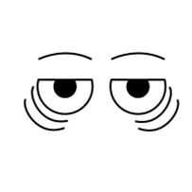
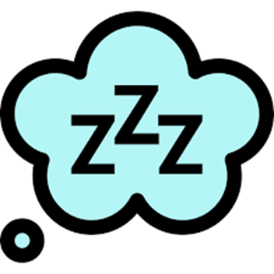
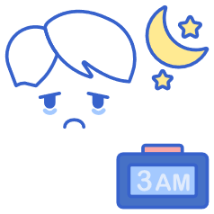

Sleep
Why did the little boy take his bicycle to bed with him?

Answer: Because he did not want to walk in his sleep

How can you go without sleep for seven days?
Answer: Sleep at night

Where does a spy sleep?
Answer: Undercover!

Why is sleep important?
- Sleep improves our immune systems and strengthens our body’s defences.
- Sleep helps our brains to work. Our mind works better when we get a good nights’ sleep. Having enough sleep can keep up focused.
- Sleep improves our moods. Lack of sleep can make us miserable and irritable. It can also bring down your energy levels.
- Lack of sleep can make feelings of depression worse.
- In puberty the brain will go through changes and will need extra sleep to help change teenagers into adults.
- Regularly getting enough quality sleep is important to help both your physical and mental wellbeing.

At this present time, our ‘normal’ daily routines have changed dramatically! Before the COVID-19 virus, you would need to be in bed at a reasonable time to be able to get up early the next morning for school. Now, how many of you are getting up at the same time as you would when you were in school? No doubt there will be lots of you who are not. How many of you are not getting up until the afternoon and going to be in the early hours of the morning?

The problem of adopting this new routine of sleeping all day and awake all night may change your ‘internal body clock’ know as your Circadian Rhythm. A circadian rhythm is a natural, internal process that regulates the sleep-wake cycle and repeats roughly every 24 hours. When we sleep your body needs enough time for it to grow muscles, repair tissues also to solidify and consolidate memories. The problem is if you sleep all day you will be awake all night! The cycle needs to be broken. While it is relatively normal for teenagers to need extra sleep, you can always make an appointment with your GP if you are concerned about other underlying causes.
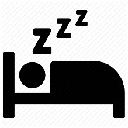
Teenagers and sleep
Teenagers on average will need between 8-10hrs of sleep each night. Why is it that teenagers come alive at night and then struggle to get out of bed in the mornings? Teenagers and parents have different body clocks!
Scientist David Bainbridge, author of "Teenagers: A Natural History" believes this is due to a 'rewiring' of the brain in adolescence which may mean that the teenage body clock runs more slowly than an adult's, making the day seem longer. When it is 8am for the rest of us, to a teenager, it feels more like 6am.
Our body produces a chemical called melatonin, this normally happens in the evening when the light dims, telling our body’s it is time to sleep. However, using devises, such as phones, TV’s consoles etc. emit enough light to stop the production of melatonin and tricks our body’s into staying awake.
What is insomnia?
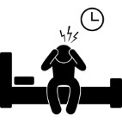
Insomnia is when you can have difficulty falling asleep or staying asleep. A person who has insomnia will often feel dissatisfied with their sleep. They can often feel, fatigue, low moods, decreased performance in work, low energy levels. Insomnia can fall into different categories based on how long it lasts, acute and chronic. Acute insomnia is brief and only lasts a short period of time. This can happen when things in our life change, for example, family situations, exams, stress, bad news. Acute insomnia will tend to correct itself in time without help. Chronic insomnia is when your sleep is disrupted at least three nights per week and lasts at least three months. This can happen when there are changes in your environment, unhealthy sleeping patterns and certain medications. Someone with chronic insomnia may benefit from seeking medical advice.
Tips for better sleep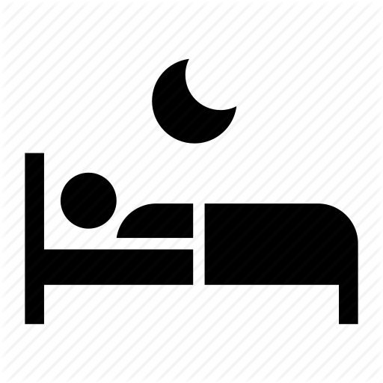
- Establish a sleep routine. Decide on what time you want to get up and work back how many hours sleep you need. Remember you only need between 8-10 hours sleep. To reset your body clock, put your alarm on for 10 minutes early each day and go to bed ten minutes early until you have the correct sleep pattern.
- Keep lights dim at night to encourage melatonin production.
- To switch off melatonin, increasing alertness go out in the sunshine during the day.
- Do not nap in the day, but if you do need a nap only rest for 30 minutes.
- Reduce caffeine intake during the evenings. For some people, caffeine can reduce the ability to sleep for up to 10 hours after it is consumed. Try a warm milky drink or herbal tea in the evening.
- Avoid stimulating activities like listening to loud music, playing computer games, and watching TV for an hour or more before bed.
- Do not eat too much too late: A overfull stomach will interfere with sleep (but do not go to bed hungry, either!).
- If stress or exam nerves are triggering insomnia, calming foods like warm milk, lettuce or turkey can help. Or try the herbal remedy valerian, which calms nerves and promotes sleep.
- Do not try and catch up on sleep at weekends: Late nights and long lie-ins further disrupt the body clock.
- Too much junk-food diet, too little exercise, smoking and alcohol will only make sleep more difficult so try and encourage a healthy lifestyle.
Useful websites
https://www.sleepfoundation.org/insomnia/what-insomnia
https://www.familylives.org.uk/advice/teenagers/health-wellbeing/teenagers-and-sleep/
https://youaremom.com/children/teenager-sleeping/
https://www.healthline.com/health-news/how-to-get-better-sleep-during-the-covid-19-outbreak
https://www.healthline.com/health/food-nutrition/warm-milk-to-sleep#1.-Anti-inflammatory-golden-milk-is-your-bedtime-go-to

Name: ___________________________________________
Sleep
C | I | R | C | A | D | I | A | N | R | H | Y | T | H | M | 1 | O
P | U | F | S | M | E | T | S | Y | S | E | N | U | M | M | I | E
S | B | E | F | D | M | M | U | T | T | F | R | H | I | M | C | D
F | C | N | S | O | A | 1 | R | R | V | T | Y | I | D | N | P | S
1 | C | S | O | E | H | A | T | E | F | H | C | T | E | T | I | F
F | F | D | H | I | L | P | P | B | S | R | 1 | C | B | M | O | E
9 | S | 9 | H | C | U | C | R | U | U | B | S | M | I | C | Y | M
S | P | B | N | P | M | C | S | P | F | E | N | S | U | I | E | H
C | O | B | I | M | H | C | D | U | L | L | E | S | U | L | P | S
H | B | 1 | P | R | L | 9 | S | O | M | R | E | 1 | A | A | H | 9
O | F | N | O | A | 1 | C | D | O | A | D | B | T | C | C | M | N
O | U | N | O | D | M | A | 9 | B | O | N | O | 1 | V | U | M | H
L | I | D | I | P | E | E | L | S | Y | N | H | F | B | T | V | R
C | A | V | 9 | R | S | E | O | U | I | L | Y | 9 | R | E | M | E
T | O | U | T | T | 1 | L | P | N | I | U | 9 | E | A | E | M | Y
C | U | H | 9 | R | S | N | M | V | O | S | O | T | I | Y | E | A
I | O | V | 1 | V | I | N | S | O | M | N | I | A | N | O | C | I
chronic Acute adolescence muscles puberty brain Circadian Rhythm melatonin moods
school COVID19 miserable focused immune systems insomnia sleep

