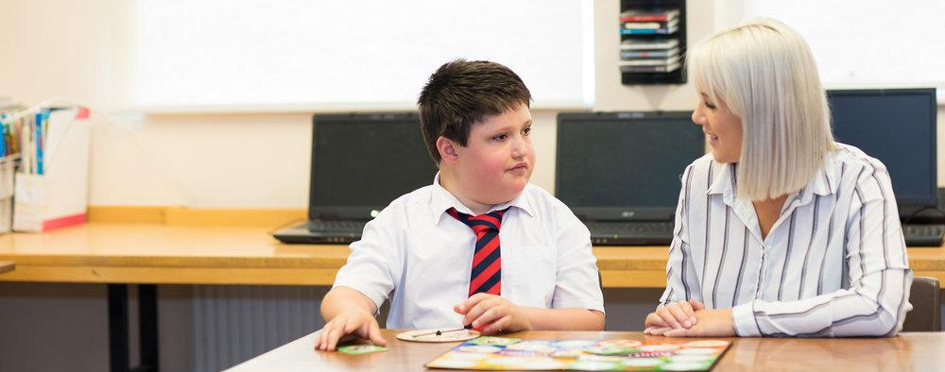

Newsletter 1:

Dear Pupils,

Welcome everyone. We are your newly appointed Lead Pupil Governors. Our role within the school is to work with the Governing Body and Senior Leadership Team to make crucial decisions on ways to support and develop Ysgol Calon Cymru.

We would like to take this opportunity to introduce ourselves to you: Eifion Davies, Maisy Wilcocks and Eleri Davies.

We are all keen musicians who always take part in competitions and further events within the school. Eifion is a keen drummer and plays is in two local bands. He is currently teaching 9 students at home and has previously been in the top 40 drummers in the UK. Maisy plays the flute, piano and enjoys singing. She is on Grade 6 with the flute and grade 5 with the piano. Eleri is working on her grade 8 piano and would love to further enhance her music by doing a Trinity College London Diploma in piano performance before she finishes her education.

Eifion and Eleri are both are active members of Rhayader YFC and are heavily involved with Wales YFC too where they compete in competitions all year round. Maisy is a gymnast at Maldwyn and Llandrindod Gymnastics club and supports coaching younger students. She has also helped lead sessions with Welsh Gymnastics during the lockdown period.

Our key focuses are to develop the following areas:

- Welsh language provision
- Wellbeing
- Teaching and learning
- Diversity and Inclusion
- ALN provision

In order to assist us with supporting you, Deputy Pupil Governors have been appointed.

Deputy Pupil Governors and subcommittees

Teaching and Learning:
Ella Lewis
Jasmine Jones
Emily Cook

Health & Wellbeing:
Rhiannon Richards
Tanwen Bradley
Scarlet Gealy

Standards and Provision:
Rhiannon Bradley
Poppy Buttitta
Annabelle Ealey-Fitzgerald

We look forward in support you as pupils and ensuring your voices are heard.

Eleri Davies, Efion Davies, Maisy Wilcocks

