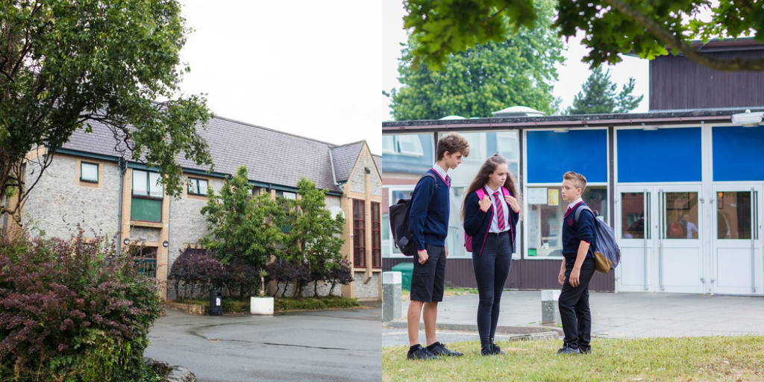

Anti Bullying Policy
Date adopted | September 2022
Signature of Headteacher | 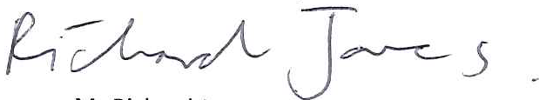
Signature of chair of governors
Review Date | September 2022

Builth Wells Campus  College Rd, Builth Wells, Powys, LD2 3BW  Tel: 01982 553 292 | Llandrindod Wells Campus  Dyffryn Rd, Llandrindod Wells, Powys, LD1 6AW  Tel: 01597 822 992

www.ysgolcalon.cymru
This policy has been produced following consultation with all stakeholders and has regard for the Welsh Government Rights, respect, equality: Statutory guidance for governing bodies of maintained schools.

The Welsh Government expects schools to adopt a whole-school approach for promoting positive, respectful behaviour between staff and learners as part of their whole-school approach to health and well-being. The Welsh Government expects this approach to be woven through all school activity, creating an environment that encourages positive behaviour and addresses the root causes of unacceptable behaviour. This will help create an inclusive, engaging environment where learners feel safe and are ready to learn.

The governing body values the good relationships fostered by the school, and expects that every allegation of bullying will be taken seriously.

All staff, pupils and parents are made aware of the negative effects that bullying can have on individuals and the school in general, and should work towards ensuring that pupils can work in an environment without fear.

Bullying is unacceptable in this school and will not be tolerated. The school also recognises that it must take note of bullying perpetrated outside school which spills over into the school. The school will do what is reasonably practicable to eliminate any such bullying and will advise pupils and parents of possible courses of action they may wish to follow in such cases.

Aims
- to demonstrate that the school takes bullying seriously and that it will not be tolerated;
- to take measures to prevent and challenge all forms of bullying in the school and during off-site activities;
- to support everyone in the actions being taken to identify and protect those who are being bullied;
- to demonstrate to all that the safety and happiness of pupils is enhanced by dealing positively with bullying.
- to promote an environment where pupils are encouraged to report bullying.
- to promote an anti-bullying culture within school.

Definition of Bullying

Bullying is behaviour by an individual or group, usually repeated over time, that intentionally hurts others either physically or emotionally.

Bullying is expressed through a range of hurtful behaviours: it can happen face-to-face or in the digital environment. It can be carried out by an individual or group but is generally executed in front of an audience to assert power or popularity. It may involve an element of secrecy so that adults are not aware of it.

Bullying differs from an argument, a fight or friendship fallout in that it:

• is deliberate or intentional
• is generally repeated over time
• involves a perceived imbalance of power between perpetrator and target
• causes feelings of distress, fear, loneliness, humiliation and powerlessness.

Bullying can take many forms, including:

• physical – kicking, tripping someone up or shoving them, injuring someone, damaging their belongings or gestures of intimidation
• verbal – taunts and name-calling, insults, threats, humiliation or intimidation
• emotional – behaviour intended to isolate, hurt or humiliate someone
• indirect – sly or underhand actions carried out behind the target’s back or rumour-spreading
• online – using any form of technological means, mobile phones, social networks, gaming, chat rooms, forums or apps to bully via text, messaging, images or video
• relational aggression – bullying that tries to harm the target’s relationships or social status: drawing their friends away, exploiting a person’s special educational needs (SEN) or long-term illness, targeting their family’s social status, isolating or humiliating someone or deliberately getting someone into trouble
• sexual – unwanted touching, threats, suggestions, comments and jokes or innuendo. This can also include sextortion, so called ‘revenge porn’ and any misuse of intimate, explicit images of the learner targeted
• prejudice-related – bullying of a learner or a group of learners because of prejudice. This could be linked to stereotypes or presumptions about identity. Prejudice-related bullying includes the protected characteristics. Prejudice can and does also extend beyond the protected characteristics and can lead to bullying for a variety of other reasons such as social status and background.

What is not bullying?

Some behaviour, though unacceptable, is not considered bullying. The school expects these instances to be dealt with in accordance with the school’s behaviour policy to prevent an incident potentially escalating to become bullying.

The following examples are cases which would not normally be considered bullying:

• friendship fallouts – a friendship feud may however deteriorate into bullying behaviour that is enabled by the fact that former friends have an intimate knowledge of the fears and insecurities of one another. Children and young people who are targeted by former friends feel the betrayal deeply and are frequently isolated from their former friendship group
• a one-off fight – the school expects it to be addressed according to the school’s behaviour policy unless it is part of a pattern of behaviour that indicates intentional targeting of another individual
• an argument or disagreement – between two children or young people is not generally regarded as bullying. Nevertheless they may require assistance to learn to respect others’ views
• a one-off physical assault – the school expects it to be stopped and addressed immediately. Police involvement in cases where physical assault has happened may also be appropriate
• insults and banter – children and young people will often protest that an incident was a joke or banter. If two friends of equal power are in the habit of bantering with one another it is not deemed to be bullying. If one learner uses banter to humiliate or threaten another who is powerless to stop it and made fearful by the act, the border between banter and bullying is likely to be crossed
• a one-off instance of hate crime – unless this behaviour is repeated it would not usually be regarded as bullying but it would be criminal behaviour, which the school would expect to be dealt with in accordance with the school’s behaviour policy and other relevant policies. If considered necessary, the school would also need to involve the police.
What motivations lie behind acts of bullying?

Children and young people who engage in bullying can have a range of motivations. They may have prejudices against certain groups in wider society. These prejudicial opinions may be informed by a wide range of factors including the following influencers: media, community and/or family values, or previous personal experience. Perpetrators’ motivations may also include a desire:

• for power, pride and popularity
• to belong to a strong in-group with a robust sense of identity and self-esteem
• to avoid being a target of bullying themselves
• to compensate for humiliations, which they themselves have suffered in the past.

The Welsh Government expects schools to consider motivations when working with children and young people who bully others. This will help with understanding and identify the root cause of the unacceptable behaviour, as well as help to change it, preventing further bullying from happening.

Signs of Bullying

Pupils who are being bullied may show changes in behaviour, e.g. becoming shy and nervous, feigning illness, taking unusual absences or clinging to adults. There may be changes in work patterns, a lack of concentration, or truancy.

All staff are aware of these possibilities and report promptly any suspicions of bullying to Wellbeing Staff

Pupils are encouraged to report incidents of bullying.

Responsibilities

Governing Body
The SLT leads on wellbeing matters will keep the Governing Body informed of anti-bullying strategies and individual cases where appropriate.

The Headteacher will:

- ensure that all staff have an opportunity of discussing strategies and reviewing them;
- determine the strategies and procedures;
- discuss development of the strategies with the SLT
- ensure appropriate training is available;
- ensure that the procedures are brought to the attention of all staff, parents and pupils; and report appropriately to the Governing Body.

The SLT lead on wellbeing matters will:

- be responsible for the day-to-day management of the policy and systems
- ensure that there are positive strategies and procedures in place to help both the bullied and perpetrator
- keep the Head informed of incidents
- arrange relevant staff training
- determine how best to involve parents in the solution of individual problems

Progress Leads (PL) and Wellbeing Team will:

- be responsible for ensuring that the school’s positive strategies are put into practice
- follow the school’s procedure regarding bullying
- investigate and deal with any incidents that are reported

Form Tutors will:

- be responsible for liaising with PL over all incidents involving pupils in their form
- be involved in any agreed strategy to achieve a solution
- deliver an ‘anti-bullying’ message

All Staff will:

- follow the policy and procedures
- be observant and investigate any issues
- deal with incidents according to the policy and pass all information to the appropriate PL
- never let any incidence of bullying pass by unreported, whether on-site or during an off-site activity
- deliver an ‘anti-bullying’ message
Anti-Bullying Education in the Curriculum

It is recognised that one-off lessons or short ‘blitz’-type activities are less likely to succeed than work embedded in the curriculum that progressively addresses relationships, positive behaviour and resilience.

Our new curriculum – Curriculum for Wales 2022 – will be introduced in September 2022 by primary schools and for Year 7, and then rolled out on a year-by-year basis. It looks to equip all our children and young people for life. It has four key purposes to support all learners to become ethical, informed, healthy and confident individuals who are ready to learn throughout their lives as they become citizens of Wales and the world. There will be opportunities across all six areas of learning and experience to embed positive behaviour and respect, not limited to the Health and Well-being Area of Learning and Experience.
Recognising good health and well-being as a key enabler of successful learning the Health and Well-being Area of Learning and Experience will support learners to develop and maintain not only their physical health and well-being, but also their mental health and emotional well-being. It will also support learners to develop positive relationships in a range of contexts. Drawing on subjects and themes from mental, physical and emotional well-being, learning in this area of learning and experience also links to how the school environment supports children and young people’s social, emotional, spiritual and physical health and well-being.
Targeted initiatives provide an opportunity to reinforce a positive and inclusive school culture. This can include awareness days, workshops, sign-posting and drop-in sessions, as well as involving the wider neighbourhood and utilising a variety of organisations. Schools should not be restricted to embarking on targeted initiatives only within dates set aside for planned prevention activities. In fact, limiting discussion of equality or discrimination issues solely to publicised or scheduled events misses numerous opportunities for ‘teachable moments’ such as what is topical in the news.
The school will raise the awareness of the anti-social nature of bullying through a whole school approach to health and wellbeing throughout the curriculum and in the RSE programme, school assemblies, the school council, newsletters, school website, pupil planner and use of tutorial time.

- The SLT Wellbeing Lead is responsible for initiating and developing with appropriate colleagues an anti-bullying programme as part of the PSE programme;
- Curriculum Leads are responsible for introducing anti-bullying material in their programmes of study as appropriate.

Changing the attitude and behaviour of perpetrators will play a major part in the strategies used by the school.

Dealing with Incidents

All reported cases of bullying must be treated seriously and dealt with on an individual basis. Care must be taken to ascertain the true facts of the situation.
Pupils should be encouraged to report all incidences of bullying to a member of staff. Pupils are likely to choose a member of staff who they personally trust to report incidents of bullying. Generally, it should be that member of staff who deals with the situation initially, but they should inform the Wellbeing Staff of the situation and make a written record of the incident – a copy of which should go to Wellbeing Staff (bullying log) and be recorded on G4S into the records of all pupils involved.
If a racial element to the bullying is suspected the SLT Wellbeing Leads must be informed immediately. All such incidents are discussed with the school Police Liaison Officer and reported to the LA.

There are a variety of intervention methods schools may choose to use. Examples of these include:

• mediation – this involves helping the perpetrator and target of bullying talk about the issue and agree on a solution
• restorative approaches – built on values, which separate the person from the behaviour. They promote accountability and seek to repair any harm caused in a situation
• building resilience – strengthening the learner’s ability to effectively cope, adjust or recover from being bullied or facing other sources of trauma, stress or adversity; equipping learners with a solid foundation or emotional resilience by ensuring that they feel accepted
• peer support – is about children and young people feeling accepted and included by other learners. It can help individuals feel like they belong in a school and can be an important factor in reducing bullying and conflict. It can be encouraged in schools in both informal and formal ways
• school sanctions – schools can use disciplinary sanctions, as set out in their school policies, to address bullying. The consequences of bullying reflect the seriousness of the incident so that others see that bullying is unacceptable.

The following procedure must be followed by all staff dealing with an incident:

Interviews should be conducted with all those involved with a view to conflict resolution.
It should be made clear to the bully how their actions are affecting the target.
In the vast majority of cases this procedure will effectively resolve the situation.
The target should be told that any further occurrence should be reported to the original member of staff who will refer the matter to the Wellbeing Staff
Any sanctions against the perpetrator will be determined by the PL.
Depending on the severity of the bullying incident one or a combination of the sanctions available to the school will apply.

When determining the most appropriate response or sanctions for addressing bullying, the Welsh Government expects schools to consider the impact a response may have more broadly and long-term on all parties involved. The Welsh Government expects schools to consider whether this is likely to help address the root causes for the bullying happening and how interventions might have the greatest impact on preventing the issue from continuing or recurring.

The Welsh Government expects schools to consider short- and longer-term interventions and give careful consideration as to whether the action is addressing the issue or simply delaying the issue happening again. For example, isolating a learner, whether the perpetrator or target of bullying, may provide a very short-term achievement of safeguarding the learner from further immediate 66 harm, but this intervention does not rebuild the self-belief of the targeted learner nor help change the behaviour of the perpetrator, and is therefore not a suitable strategy for addressing the root cause of the issue or providing a medium- or long-term solution.

Bullied Pupils

Staff who deal with pupils who have been bullied must always offer reassurance. Pupils who have been bullied will be given support determined by the Wellbeing Staff / PL.
Those who are targets of bullying behaviour tend to feel powerless. One of the first steps when responding to incidents is to work to restore their capacity to make choices for themselves. Using effective listening techniques, staff (or a peer supporter where these are used) can help the targeted learner to feel they are doing something about the problem. Acknowledge calmly the anger or distress of the targeted child or young person speaking. If they need time to process their thoughts or articulate the story, try not to rush them. Staff should be mindful that it may have required considerable courage to come and report what is happening. Thank the learner for reporting the problem. Explain to them the next steps of how their concerns will be taken forward. This will help to reassure them that their concerns are being taken seriously.

The Welsh Government expects learners who are bullied to be encouraged, where possible, to keep evidence of the activity. Evidence may be threats or images sent on or offline by messaging, conversations, notes or images, damaged clothing or other belongings, online conversations or notes. Bystanders may also be able to provide witness statements or additional evidence. Dates and times when things happened should be noted. Screen grabs can be saved as online evidence.

Perpetrators

Changing the attitude and behaviour of perpetrators will be part of any procedures used to combat bullying. However, the school recognises that sanctions will also have to be used against perpetrators.
Alongside the support provided to targets of bullying, the Welsh Government expects schools to recognise that those who perpetrate bullying of others also need help, support and opportunities to change their behaviour and to ensure that they receive these. Effective listening can be used along with teaching relationship skills to those who bully others. The Welsh Government expects them to be guided to recognise and handle their difficult feelings and to learn positive communication skills. Bullying behaviour can be a sign of some bigger problem at school, home or elsewhere in a child or young person’s life

Involvement of Parents

Parents, as well as all staff and pupils, should know that the school will not tolerate bullying, and takes a positive approach to educating pupils to combat it.
Parents will be informed of the policy and procedures following acts of bullying.

Involvement of Pupils/Students

Pupils will be involved in the positive strategies through both the school council and tutor groups. Pupils will have an input into the PSE anti-bullying programme, and will be consulted on how it could be developed.

Strategies for Dealing with Bullying

Useful advice can be found in the Welsh Government Rights, respect, equality: Statutory guidance for governing bodies of maintained schools. The pack gives guidance on whole-school policies, pupils’ experiences, finding out about bullying in school, strategies to combat bullying, working with parents, beyond the classroom, and advice for pupils, parents and families, along with case studies and advice on materials.

Where to find further help and advice
Bullying Bullies Out – Anti-bullying charity based in Wales that works with individuals, schools, colleges, youth and community settings. E-mentors offer online support (e-mail mentorsonline@bulliesout.com). www.bulliesout.com e-mail: mail@bulliesout.com Anti-Bullying Alliance – Information for schools, parents/carers and children and young people on all aspects of bullying. www.anti-bullyingalliance.org.uk Kidscape – Anti-bullying charity that runs workshops for children and young people who have been bullied. www.kidscape.org.uk

Counselling

The school is prepared in appropriate cases to arrange counselling for both perpetrators and the bullied.

Reporting and Recording

All incidents must be reported and recorded on our electronic discipline records for all involved.
Routes to report
The Welsh Government expects schools to offer a range of ways for learners to report bullying. These can include:

• trained peer supporters or ‘buddies’
• a quiet and private space to talk
• anti-bullying pastoral leads and staff available at key times
• school nurses or counsellors
• feedback boxes

Staff Training

The SLT member responsible for arranging a programme of staff development, will arrange training at regular intervals on anti-bullying strategies. This will include training for support staff and governors as well as teachers.

Monitoring and Review

The Pastoral Leader will monitor reports on serious incidents. The Head will consider the reports with the Leadership Team to determine what can be learned from the incidents and how they were handled with a view to improving the school’s strategies.

