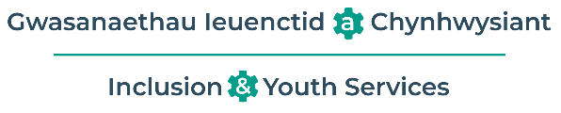
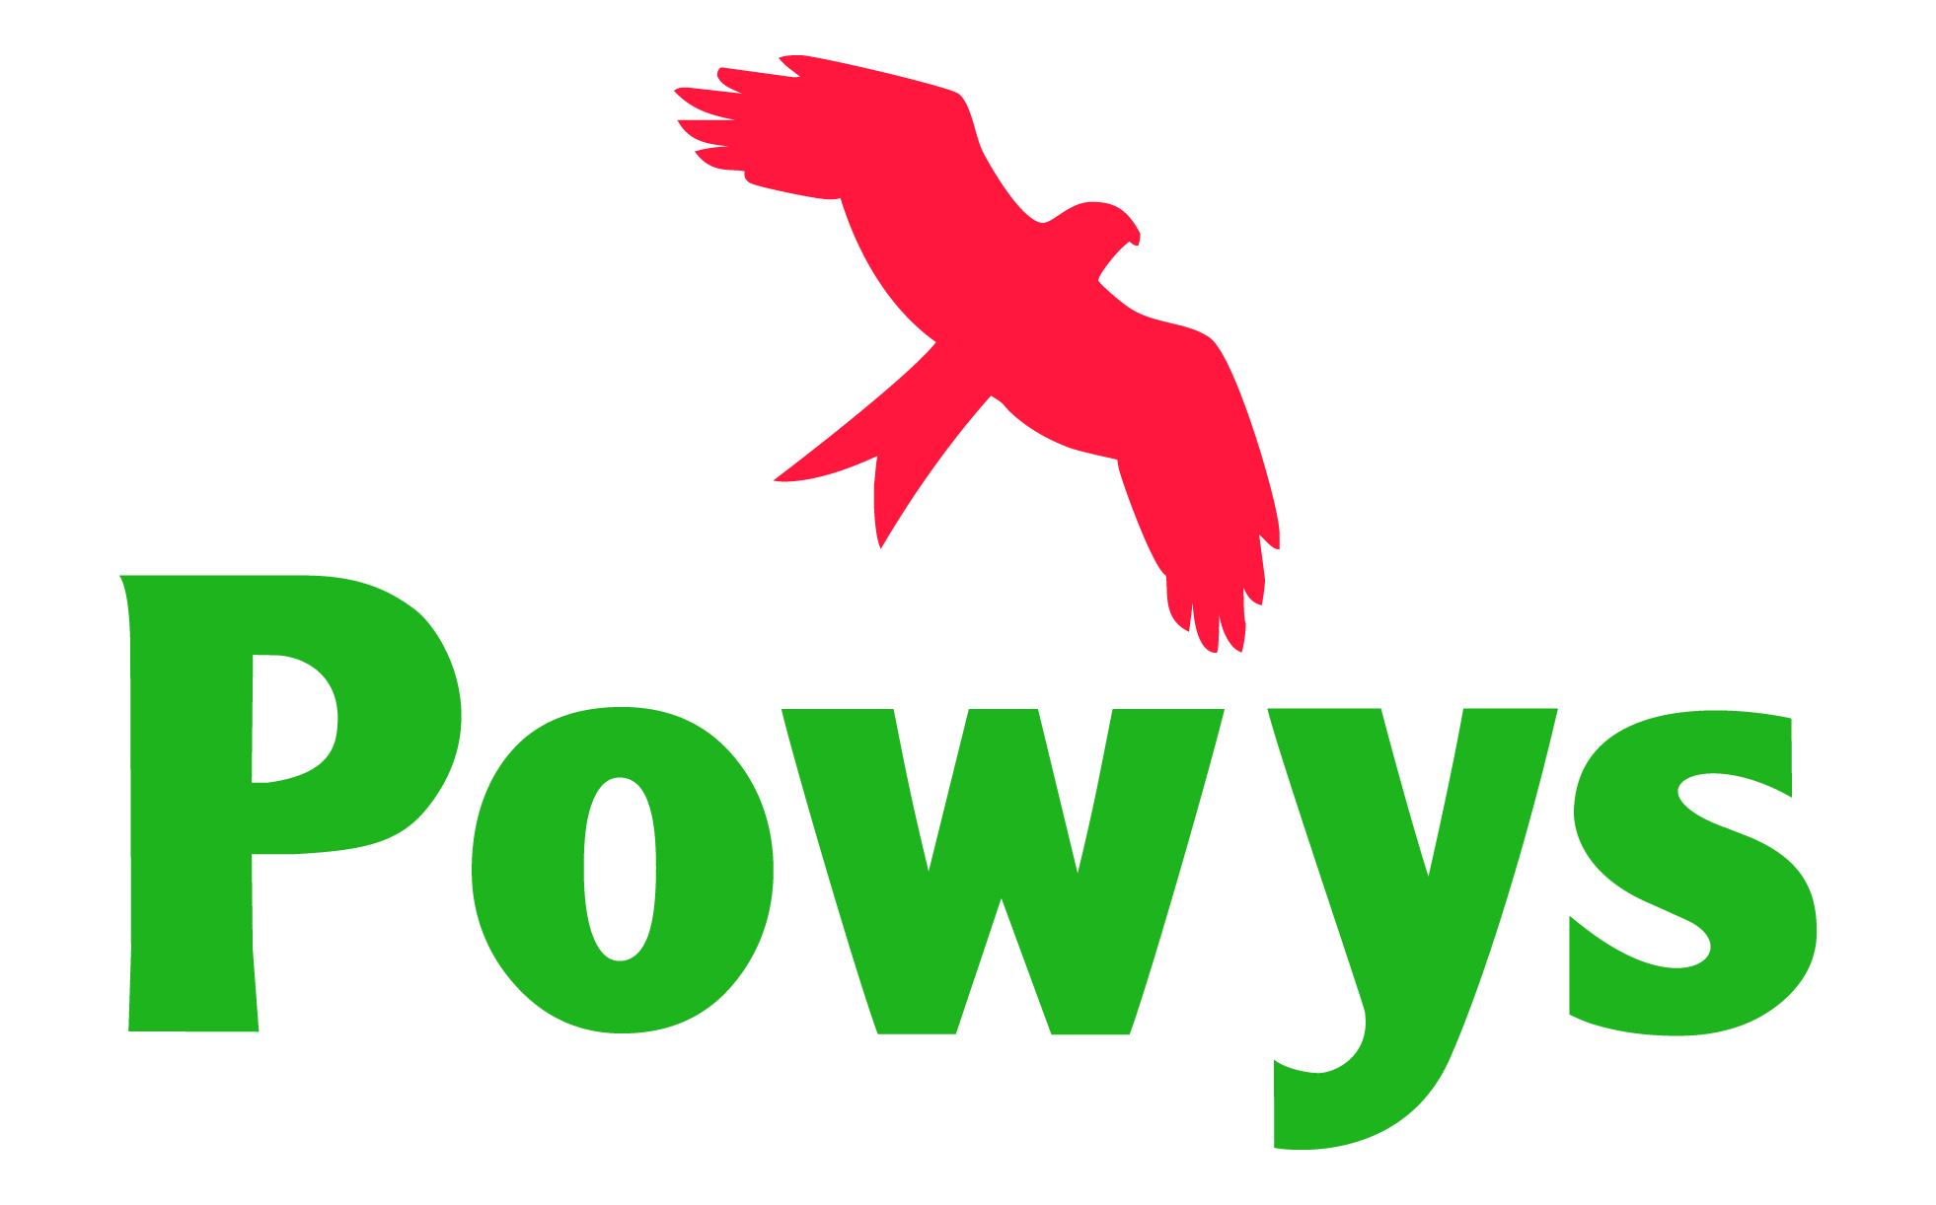

Annwyl Rieni,  Mae’r Tîm Anghenion Dysgu Ychwanegol (ADY) a Chynhwysiant wrthi’n treialu Sesiynau Galw Heibio Rhithwir i Rieni.  Bydd aelodau o’r Timau Blynyddoedd Cynnar ac ADY ysgolion yn rhedeg y sesiynau hyn.  Bydd yn gyfle i chi drafod urnhyw gweistynau ADY a allai fod gennych, a chyfarfod â’r tîm.  Cynhelir y sesiwn gyntaf ddydd Iau 30 Tachwedd 12-2pm.  Cliciwch ar y ddolen isod i gael mynediad i’r sesiwn.  Click here to join the meeting  Edrychwn ymlaen at eich gweld yno. | Dear Parents,  The Additional Learning Needs (ALN) and Inclusion Team are trialling Virtual Parent Drop Ins.  These will be run by members of the Early Years and School’s ALN Teams.  This will be an opportunity for you to discuss any ALN questions you may have and meet the team.  The first session will take place on Thursday 30th November 12-2pm.  Please click the link below to access the session.  Click here to join the meeting  We look forward to seeing you there!

