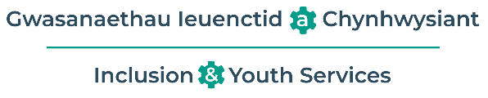
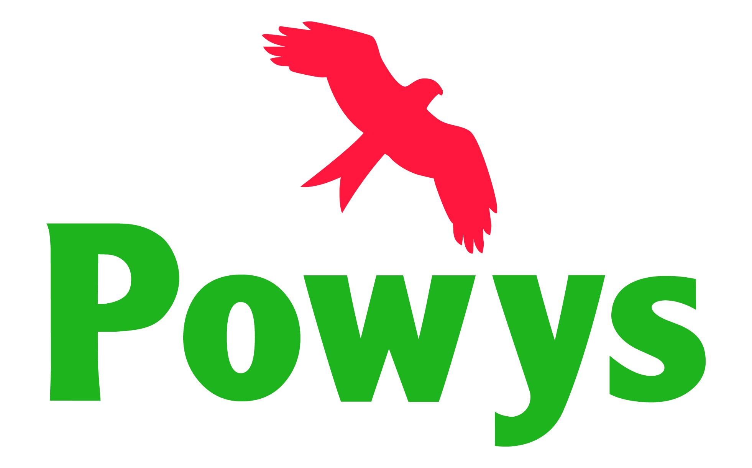

Annwyl Rieni,  Mae’r Tîm Anghenion Dysgu Ychwanegol (ADY) a Chynhwysiant wrthi’n treialu Sesiynau Galw Heibio Rhithwir i Rieni.  Bydd aelodau o’r Timau Blynyddoedd Cynnar ac ADY ysgolion yn rhedeg y sesiynau hyn.  Bydd yn gyfle i chi drafod urnhyw gweistynau ADY a allai fod gennych, a chyfarfod â’r tîm.  Y sesiynau nesaf yw:  1Chwefror 2024 12:00-13:00  Cliciwch ar y ddolen isod i gael mynediad i'r sesiwn.  Microsoft Teams meeting  Join on your computer, mobile app or room device  Click here to join the meeting  1 Chwefror 2024 17:00-18:00  Cliciwch ar y ddolen isod i gael mynediad i'r sesiwn.  Microsoft Teams meeting  Join on your computer, mobile app or room device  Click here to join the meeting  Edrychwn ymlaen at eich gweld yno! | Dear Parents,  The Additional Learning Needs (ALN) and Inclusion Team are trialling Virtual Parent Drop Ins.  These will be run by members of the Early Years and School’s ALN Teams.  This will be an opportunity for you to discuss any ALN questions you may have and meet the team.  The next sessions are:  1st February 2024 12:00-13:00  Please click the link below to access the session.  Microsoft Teams meeting  Join on your computer, mobile app or room device  Click here to join the meeting  1st February 2024 17:00-18:00  Please click the link below to access the session.  Microsoft Teams meeting  Join on your computer, mobile app or room device  Click here to join the meeting  We look forward to seeing you there!

