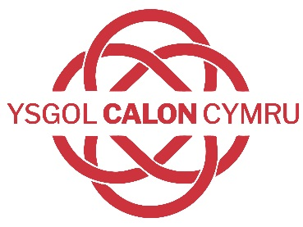

The School at the Heart of Wales

Dear Parents/carers 23.09.22

I hope you and your families are well and are enjoying the beginning of Autumn. So far, the start back in school this term has been a positive one across both our campuses'; our pupils have settled quickly into routine and it is clear that they are enjoying and engaging with their learning.

The purpose of this letter is to inform you that the school has had notification of our ESTYN inspection the week beginning Monday October 3rd. During that week, a team of ESTYN inspectors will visit the school to scrutinise the school’s progress, identifying areas of strength and those for development. Further information about the inspection process can be found in the accompanying document.

As part of the inspection process, ESTYN would like to hear your views on the school and our progress. Please can I ask you to follow the link below to access the ESTYN survey. Your feedback on the school will form an important part of the evidence used to evaluate the school, so please can I encourage you to complete the short ESTYN survey.

Parent/carer questionnaire: |  | https://www.smartsurvey.co.uk/s/MRNBSV/

In addition to the survey, the team from ESTYN would also like to hold a face-to-face meeting with parents/carers so you can share your views in person. This meeting will be held in the Bwty on the Builth Campus at 5pm on Monday 3rd October. If you would like to attend this meeting, please indicate your attendance by emailing us on office@caloncymru.powys.sch.uk

Refreshments will be available during the session and for those of you who will need to attend with young children, we will be running an art workshop that they can attend.

Thank you for your continuing support.

Dr. Richard Jones

Headteacher/ Pennaeth

Ysgol Calon Cymru

