Prosiect Pride Ysgol Calon Cymru

Ysgol Calon Cymru are very proud to show their support for LGBT inclusivity within the school setting. We are in early stages of developing a permanent event within our school calendar. We have connected with Powys Pride and before lockdown were supposed to be participating in Powys first ever Pride event. This has now become a virtual event and will be involved. We fully support Equality and Diversity at Ysgol Calon Cymru.
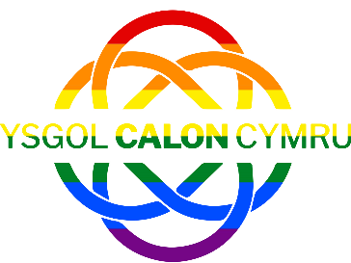
The aim of this project is to outline the next steps for Ysgol Calon Cymru. Prosiect Pride has been set up off the back of the Staff and student’s pride video, which was viewed over 8,000 times and shared 50 times. The video proved to be a fantastic success and I believe we are now ready to move Ysgol Calon Cymru forward with in becoming an LGBT Visible school.
The early steps of the project have already taken place. Back in the summer term we showed the Pride video to every pupil who came to school and the response was very positive. Following a number of meetings / informal conversations with the pastoral team, we have a clear path forward with the next steps.
The school has contacted Stonewall Cymru which was a huge success as we now have a collaborative working relationship to build on the school’s awareness of being an LGBT Visual school. Stonewall have very kindly offered training and support in many different aspects and we are very grateful for this opportunity.
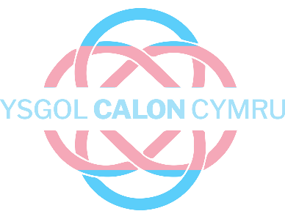
One of the next steps of ‘Prosiect Pride’ is how the school can show support of its LGBT students and staff, by becoming an Ally. The way in which we will do this is by creating a working party with students through a virtual lunchtime session where by we can ask the pupils how would they like the school to become an ally.
Gender Identity can have its confusion with many people, not because they have an issue with it, but more they don’t know how to address the language that’s appropriate and acceptable to use. Below is an example of what we have on our Pride board in school.

