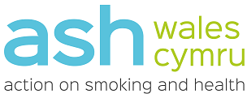

ASH Wales Cymru
Tel: 029 2049 0621
enquiries@ashwales.org.uk

ash.wales

Dear Parent or Guardian,

We write to inform you that students will be participating in a national online survey on the topic of vapes. The use of vapes among young people has become an area of concern, this survey, conducted by ASH Wales, will help inform action at a local and national level.

It contains questions on vaping, smoking, cannabis, and where and how students are accessing vaping products. The survey takes between 5 – 10 minutes to complete. It is anonymous and students do not have to answer the questions.

All entries will be anonymous:
Pupils will not be traceable from their submissions of the survey; therefore, we encourage that they be as honest as possible in their responses. Information gathered will help inform local authority action.

We welcome any questions you may have about the survey or how the data will be used. We appreciate your cooperation and look forward to providing an informative analysis of the survey results.

Anyone with information on the sale of illegal vapes or underage sales can report it anonymously through the No Ifs No Butts website. We would encourage parents and students to use this website to support local action.

Kind regards
ASH Wales

