26TH FEBRUARY 2023

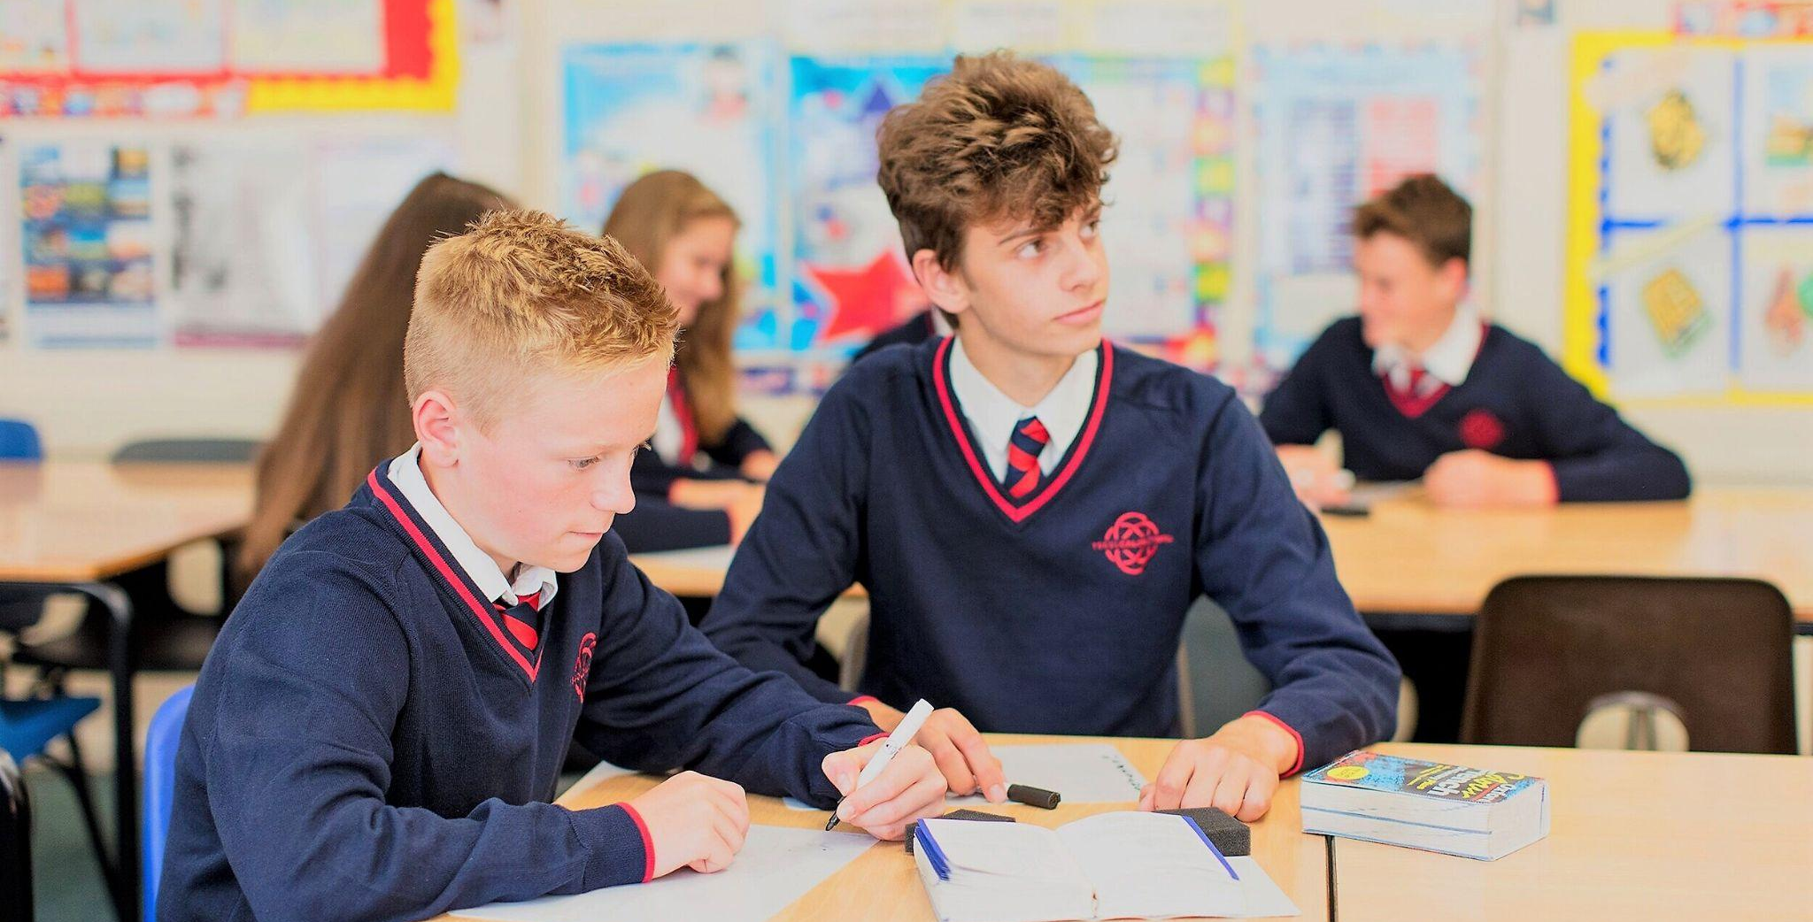

NEU Strike: Thursday 2nd March 2023

Dear Parents and Carers,

As you will be aware, members of the NEU teaching union are holding a second day of industrial action on Thursday 2nd March 2023. In Ysgol Calon Cymru we have a large number of staff who belong to the NEU, so, to ensure proper Health and Safety, I have had to take the decision to restrict the number of pupils who can attend school on that date.

What pupils can attend school?

On Thursday 2nd March, school will be closed for all pupils except:

- Pupils on planned external trips and educational visits.

These trips and visits will still take place and we will communicate with the parents and carers of these pupils separately.

Why can't all pupils attend and be taught by non-striking teachers or supply teachers?

Under the terms of the industrial action we are not allowed to replace teachers during the strike with non-striking teachers or supply agency staff. Part of the conditions of the strike action is that classes are left untaught.

For pupils not in school, will there be online learning?

For pupils who are not in school, online learning will be provided for some of their classes. Online learning will be provided by those staff who are in-school and not striking. HOWEVER, under the terms of the industrial action, online learning will not be provided for those classes where a teacher is on strike.

How will my child know if a teacher is on strike or not?

Your child will not know if there is online learning until they check the TEAMS page for a particular class. It is not possible to give advance notice of what online learning will be available, as a list of striking teachers cannot be published.

What if my child logs-on to the TEAMS page for a class and finds no work?

In this situation, I would encourage our pupils to complete work from another subject area, and for exam classes to use the time to revise/self-study or to access the learning resources on the school website.

My child is entitled to Free School Meals, will provision be available?

For those pupils entitled to free school meals, a packed lunch will be available to pick up from the school canteen at lunchtime. If you require a packed lunch for your child, please could you contact the school office to order in advance.

What will happen with the planned Year 9 Parents Evening?

Due to the strike we will also need to reschedule the planned Year 9 Parents Evening. I will write to all parents/carers of Year 9 pupils in s separate newsletter to confirm our new arrangements.

As ever, thank you for your support and we look forward to seeing all pupils back on campus on Friday 3rd March.

Cofion Cynnes,
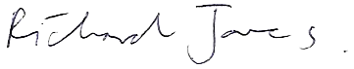

Dr. Richard Jones
Headteacher, Ysgol Calon Cymru

